Project OMIS 661 – Business Intelligence Apps and Tools

TYPE1: You are asked to use Microsoft Power BI tool to analyze data from WildWorldImportersDW (SQL Server) and provides useful information and recommendations to the company.

|  |  |  |
| --- | --- | --- |
| **TABLE OF CONTENTS** | | |
| **Sr.No.** | **Topic** | **Page Number** |
| **1** | **Introduction of Dataset**  **(about dataset: WideWorldImportersDW)** | **2** |
| **2** | **Flow of Project**  **(Steps from beginning to the end of my project)** | **2** |
| **3** | **Tables Used in Analysis**  **(Tables used for analysis and visualization)** | **3** |
| **4** | **Data Cleaning**  **(data preprocessing like eliminating null values, spliting columns, creating columns using some formulas, creating measures etc )** | **7** |
| **5** | **Data Modeling**  **(diagram view shows the relationship between tables)** | **21** |
| **6** | **Analysis and Visualization**  **(using various charts and artificial intelligence techniques of power BI)** | **22** |
| **7** | **Publishing in power bi**  **(reports and dashboards)** | **35** |
| **8** | **Recommendations**  **(conclusion based on analysis)** | **36** |

**INTRODUCTION OF DATASET:**

**Wide World Importers** is an imaginary importer and distributor of novelty goods based in the San Francisco Bay Area and spread all over United States.

So as the dataset is an imaginary, I have some assumptions from the company side and performed analysis based on assumptions.

As from data company is making good profit over time but still they are in loss on some products, and they want to know how to improve sales on those products and make 100% profit on all products.

So, by taking considerations of few factors on brainstorming I performed below analysis to help company to identify the data pattern and can provide useful recommendations based on the company’s concerned.

**There is total 6 modules and 29 tables in data set**

6 Modules: Movement, Order, Sale, Purchase, Stock Holding, Transaction

Among 29 tables out of which **8 tables are dimension tables and 6 are fact tables** and rest all used for ETL process.

Technologies used throughout this project:

* SQL Server management studio 2017
* Power BI
* Word
* Power point

**FLOW OF PROJECT:**

* Analyzing modules of data set – WideWorldImportersDW
* Understanding Company’s requirements (Created based on my assumptions)
* Brainstorming few factors on company’s concerned.
* Import dataset in Power BI
* Cleaning data by Splitting columns, removing unwanted columns, Removing null values etc.
* Shaping data by creating hierarchies and creating new measures to do better analysis and visualization.
* Data modeling based on some modules.
* Visualizations in Power BI
* Publishing in Power BI
* Creating reports and dashboards by publishing in PowerBI.
* Provide useful recommendations

**TABLES USED IN ANALYSIS:**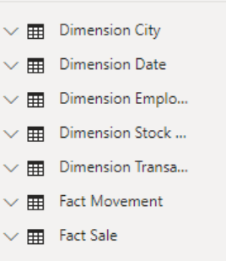

**Dimension.City**: Used by Fact. Sale

|  |  |  |
| --- | --- | --- |
| Number | Name | Description |
| 1 | 🔑City Key | DW key |
| 2 | WWI City ID | Numeric ID for database referal |
| 3 | City | Name of the city |
| 4 | State Province | Name of the State |
| 5 | Country | Country Name |
| 6 | Continent | City’s continent |
| 7 | Sales Territory | Sales territory for this StateProvince |
| 8 | Region | Region Name |
| 9 | Subregion | Name of the Subregion |
| 10 | Latitude | One of the Geographic locations |
| 11 | Longitude | One of Geographic location |
| 12 | Latest Recorded Population | Latest available population for a particular city |
| 13 | Valid From | Valid from this date and time |
| 14 | Valid to | Valid until this date and time |
| 15 | Lineage Key | Has a foreign key relationship for ETL Process |

**Dimention.Date:** Used by fact. Movement, fact. Sale

|  |  |  |
| --- | --- | --- |
| Number | Name | Description |
| 1 | 🔑Date | DW key for date dimension (actual date is used for key) |
| 2 | Day number | Day of the month |
| 3 | Day | Day name |
| 4 | Month | Month name (i.e., September) |
| 5 | Short month | Short month name (i.e., Sep) |
| 6 | Calendar Month Number | Calendar month number |
| 7 | Calendar month label | Calendar month label (i.e., CY2015Jun) |
| 8 | Calendar year | Calendar year (i.e., 2015) |
| 9 | Calendar year label | Calendar year label (i.e., CY2015) |
| 10 | Fiscal month number | Fiscal month number |
| 11 | Fiscal month label | Fiscal month label (i.e., FY2015Feb) |
| 12 | Fiscal year | Fiscal year (i.e., 2016) |
| 13 | Fiscal year label | Fiscal year label (i.e., FY2015) |
| 14 | ISO week number | ISO week number (i.e., 25) |
| 15 | Week Day | Name of weekdays |
| 16 | WeekDayOrder | Number of weekday |

**Dimension.Employee:** used by Fact.sale.

|  |  |  |
| --- | --- | --- |
| **Number** | **Name** | **Descrition** |
| 1 | 🔑Employee key | DW key for the employee dimension |
| 2 | WWI employee ID | Numeric ID (personID) in the WWI database |
| 3 | Employee | Full name for this person |
| 4 | Employee FullName | Name that this person prefers to be called |
|  | Employee FirstName | First name of Emplyoee |
|  | Emplyoee LastName | Last name of Emplyoee |
| 5 | Is Salesperson | Is this person a staff salesperson? |
| 6 | Valid from | Valid from this date and time |
| 7 | Valid to | Valid until this date and time |
| 8 | Lineage key | Has a foreign key relationship for ETL Process |

**Dimension.Stock Item: U**sed by Fact.Movement, Fact.Sale

|  |  |  |
| --- | --- | --- |
| **Number** | **Name** | **Description** |
| 1 | 🔑Stock item key | DW key for the stock item dimension |
| 2 | WWI Stock Item ID | Numeric ID used for reference to a stock item within the WWI database |
| 3 | Stock Item | Full name of a stock item (but not a full description) |
| 4 | Color | Color (optional) for this stock item |
| 5 | Selling package | Usual package for selling units of this stock item |
| 6 | Buying package | Usual package for selling outers of this stock item (i.e., cartons, boxes, etc.) |
| 7 | Brand | Brand for the stock item (if the item is branded) |
| 8 | Size | Size of this item (eg: 100mm) |
| 9 | Lead time days | Number of days typically taken from order to receipt of this stock item |
| 10 | Quantity per outer | Quantity of the stock item in an outer package |
| 11 | Is Chiller Stock | Does this stock item need to be in a chiller? |
| 12 | Barcode | Barcode for this stock item |
| 13 | Tax rate | Tax rate to be applied |
| 14 | Unit price | Selling price (ex-tax) for one unit of this product |
| 15 | Recommended retail price | Recommended retail price for this stock item |
| 16 | Typical weight per unit | Typical weight for one unit of this product (packaged) |
| 17 | Photo | Photo of the product |
| 18 | Valid from | Valid from this date and time |
| 19 | Valid to | Valid until this date and time |
| 20 | Lineage key | Has a foreign key relationship for ETL Process |

**Dimension.Transaction Type:** used by Fact.Movement

|  |  |  |
| --- | --- | --- |
| Number | Name | Description |
| 1 | 🔑Transaction type key | DW key for the transaction type dimension |
| 2 | WWI transaction type ID | Numeric ID used for reference to a transaction type within the WWI database |
| 3 | Transaction type | Full name of the transaction type |
| 4 | Valid from | Valid from this date and time |
| 5 | Valid to | Valid until this date and time |
| 6 | Lineage key | Has a foreign key relationship for ETL Process |

**Fact.Movement:** uses Dimension.Date, Dimension.Stock item, Dimension.Transaction type.

|  |  |  |
| --- | --- | --- |
| **Number** | **Name** | **Description** |
| 1 | 🔑Movement key | DW key for a row in the movement fact identity |
| 2 | Date key | Transaction date |
| 3 | Stock item key | Stock item for this purchase order |
| 4 | Customer key | Customer (if applicable) |
| 5 | Supplier key | Supplier (if applicable) |
| 6 | Transaction type key | Type of transaction |
| 7 | WWI Stock item transaction ID | Stock item transaction ID in source system |
| 8 | WWI invoice ID | Invoice ID in source system |
| 9 | WWI purchase ID | Purchase order ID in source system |
| 10 | Quantity | Quantity of stock movement (positive is incoming stock, negative is outgoing) |
| 11 | Incoming Stock | Stocked in company |
| 12 | Outgoing Stock | Unstocked from company |
| 13 | Lineage key | Has a foreign key relationship for ETL Process |

**Fact.Sale**: Uses Dimension.city, Dimension.date, Dimension.employee, Dimension.stock item.

|  |  |  |
| --- | --- | --- |
| **Number** | **Name** | **Description** |
| 1 | 🔑Sale key | DW key for a row in the sale fact identity |
| 2 | City key | City for this invoice |
| 3 | Customer for this invoice | Customer for this invoice |
| 4 | Bill to customer key | Bill to customer for this invoice |
| 5 | Stock item key | Stock item for this invoice |
| 6 | Invoice date key | Invoice date for this invoice |
| 7 | Delivery date key | Date that these items were delivered |
| 8 | Salesperson key | Salesperson for this invoice |
| 9 | WWI Invoice ID | InvoiceID in source system |
| 10 | Description | Description of the item supplied (usually the stock item name but can be overridden) |
| 11 | Package | Type of package supplied |
| 12 | Quantity | Quantity supplied |
| 13 | Unit price | Unit price charged |
| 14 | Tax rate | Tax rate applied |
| 15 | Total excluding tax | Total amount excluding tax |
| 16 | Tax amount | Total amount of tax |
| 17 | Profit | Total amount of profit |
| 18 | Total including tax | Total amount including tax |
| 19 | Total dry items | Total number of dry items |
| 20 | Total chiller items | Total number of chiller items |
| 21 | Lineage key | Has a foreign key relationship for ETL Process |

**DATA CLEANING:**

Importing dataset from Sql Server 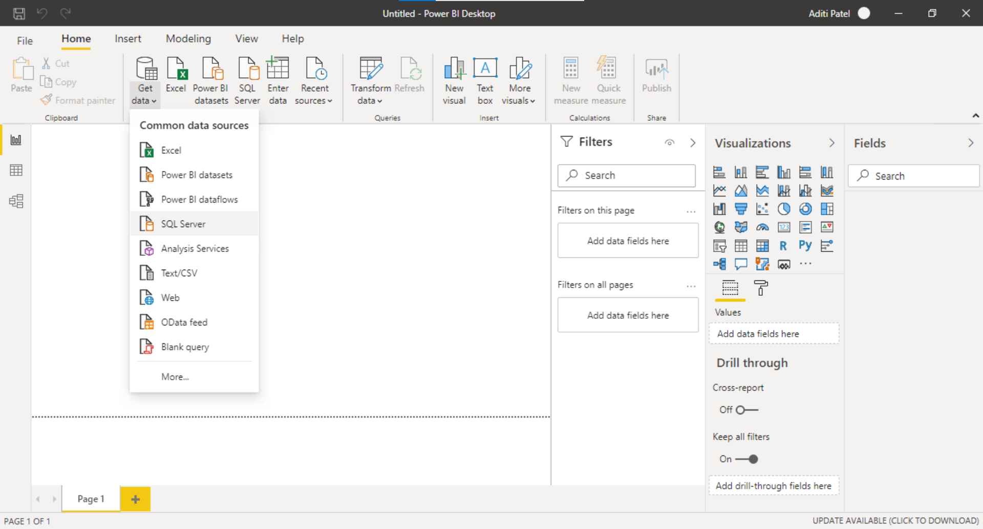

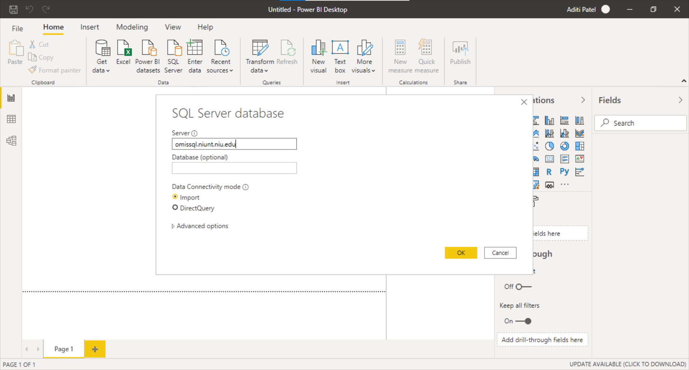

Importing tables from database which are required for analysis for now.

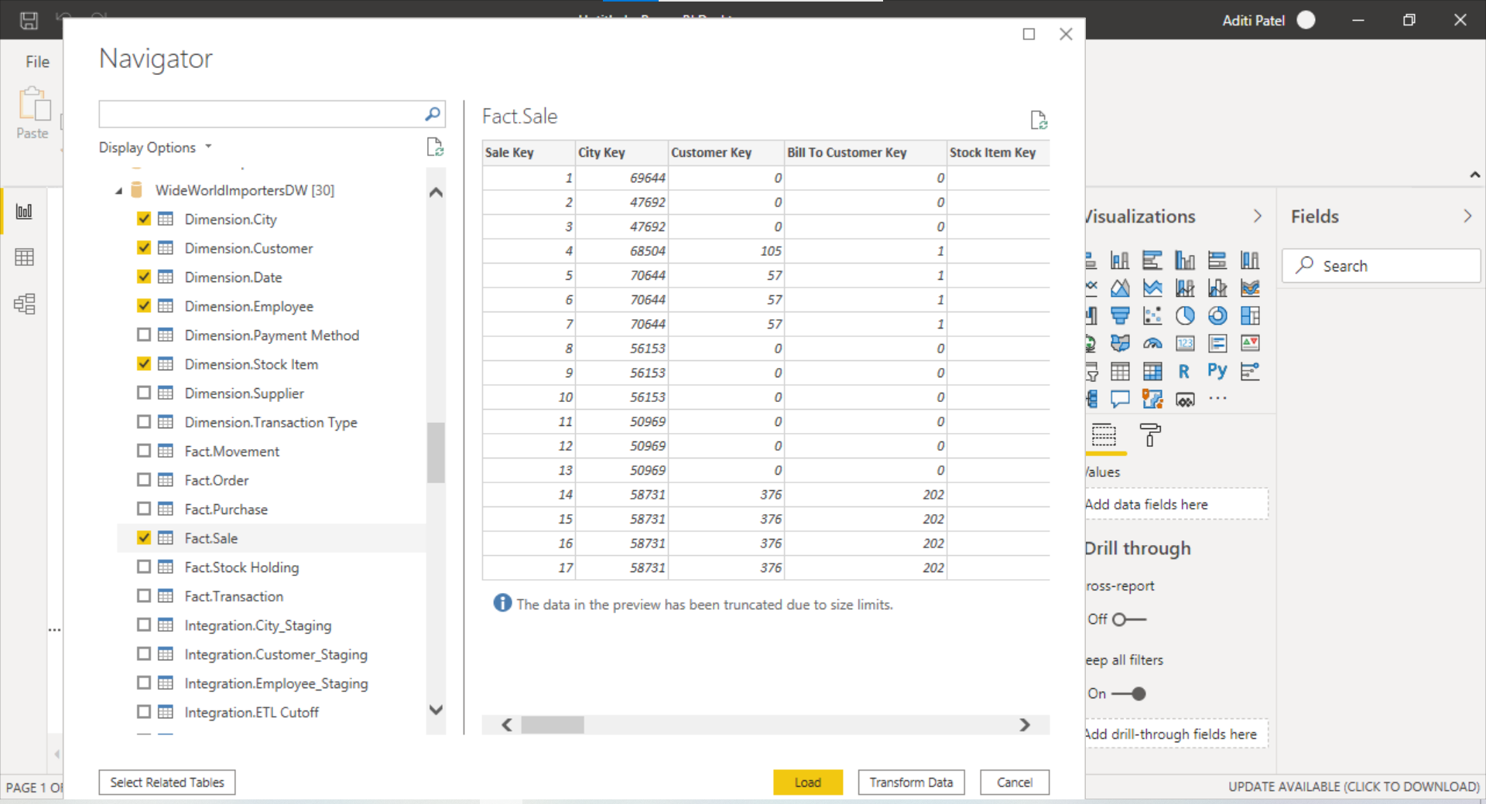

Remove Null values

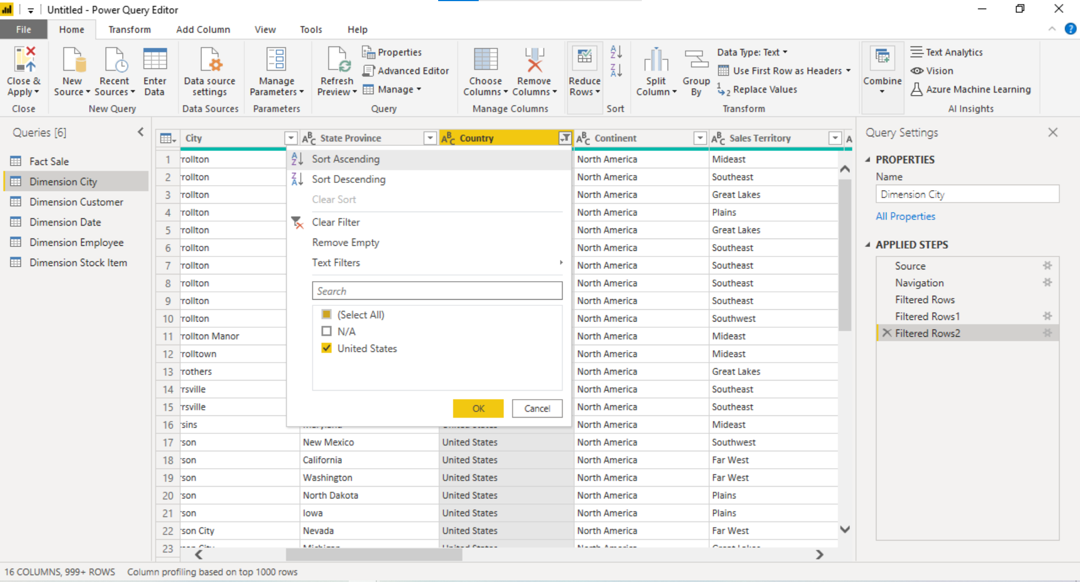

Location column shows the geographic data, and it has values of longitude and latitude. So split the columns into longitude and latitude

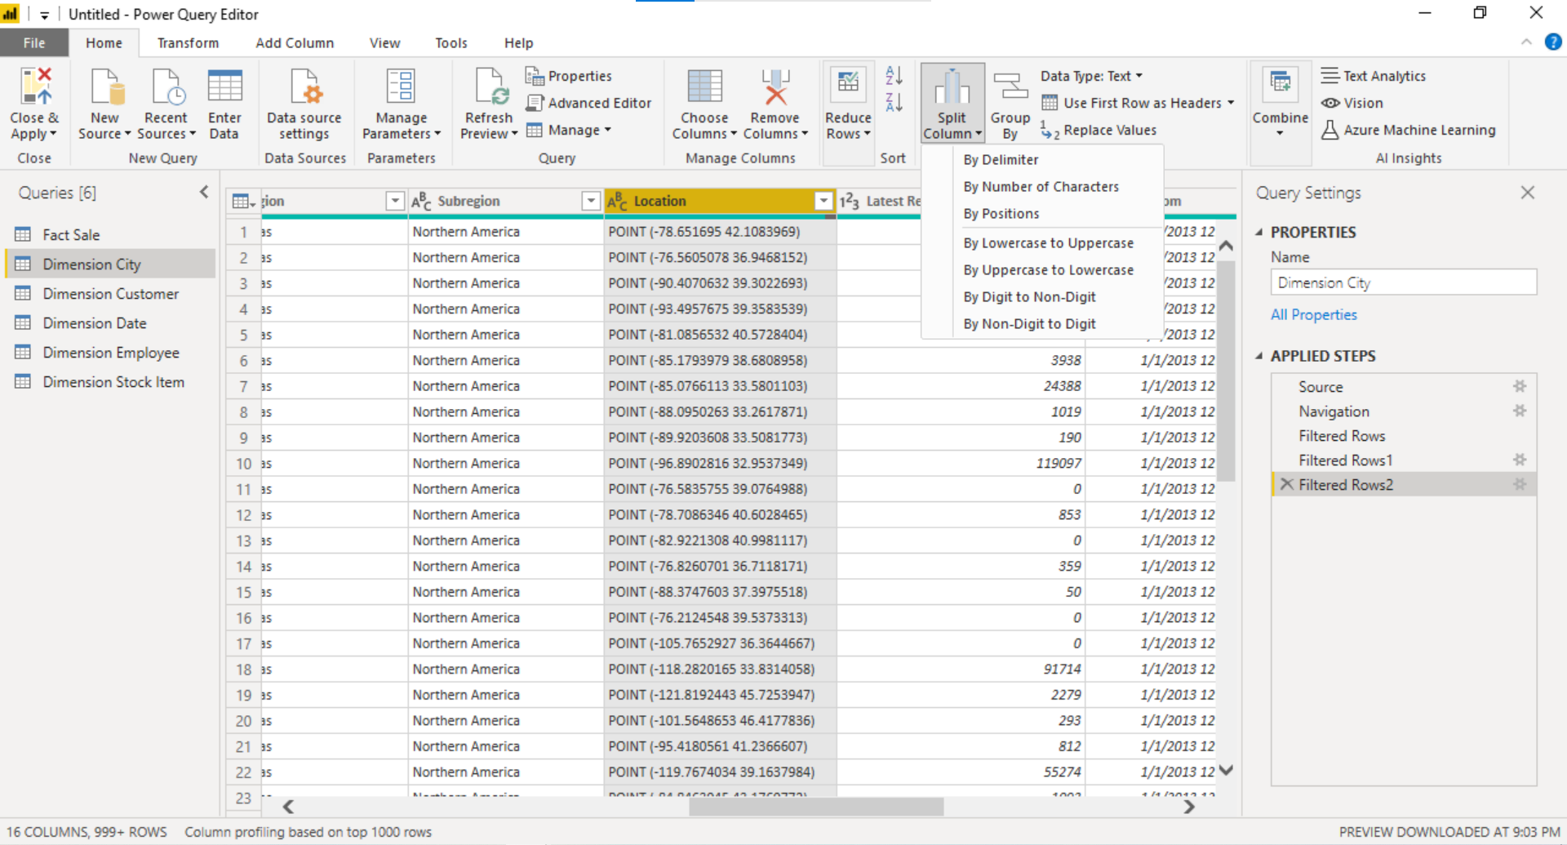

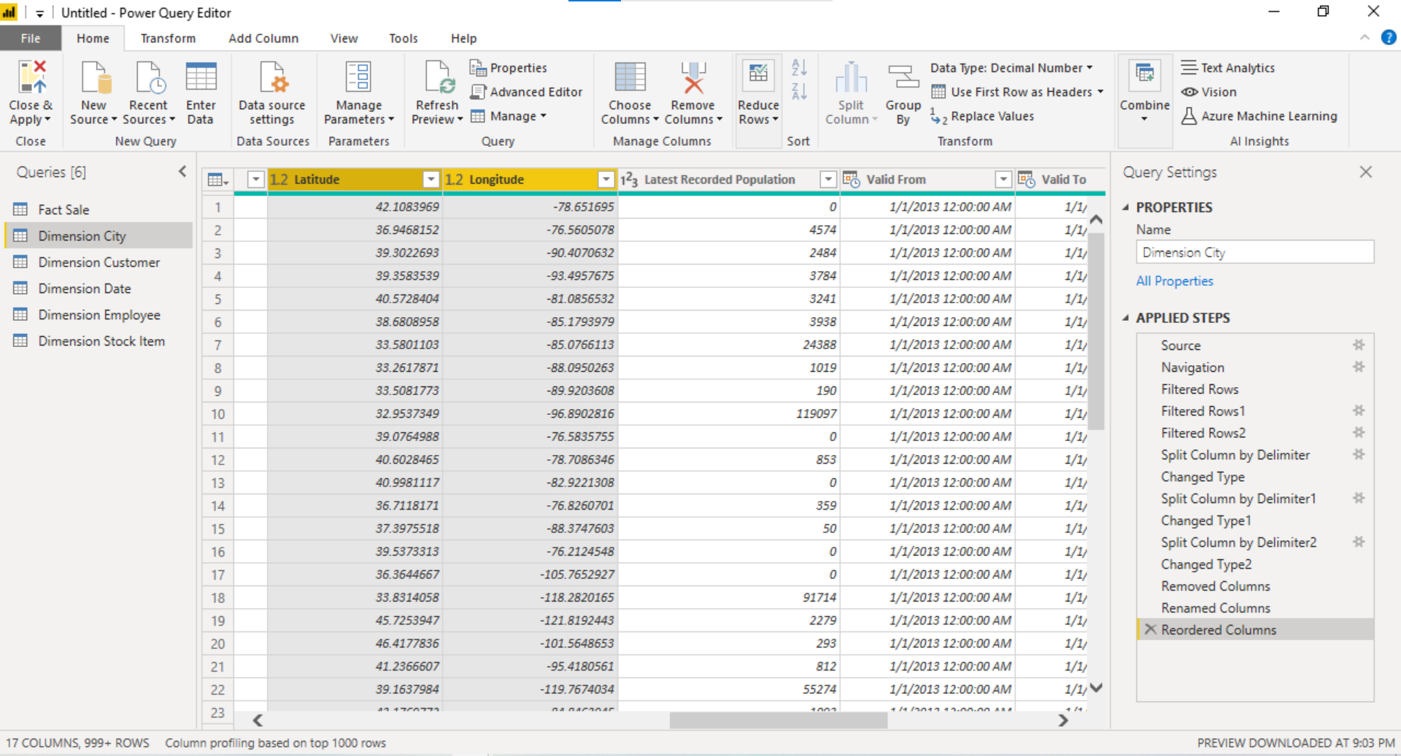

Filtered unknown values in Employee column.

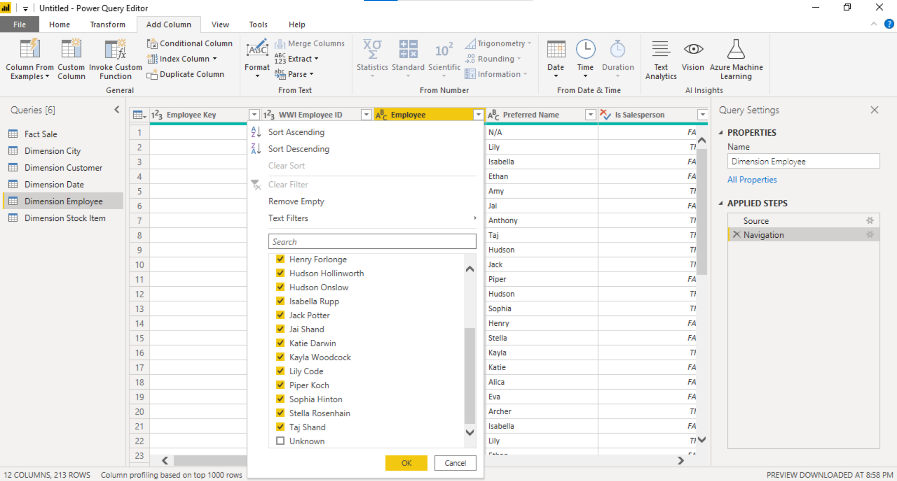

Split columns of Employee into its First name and last name.

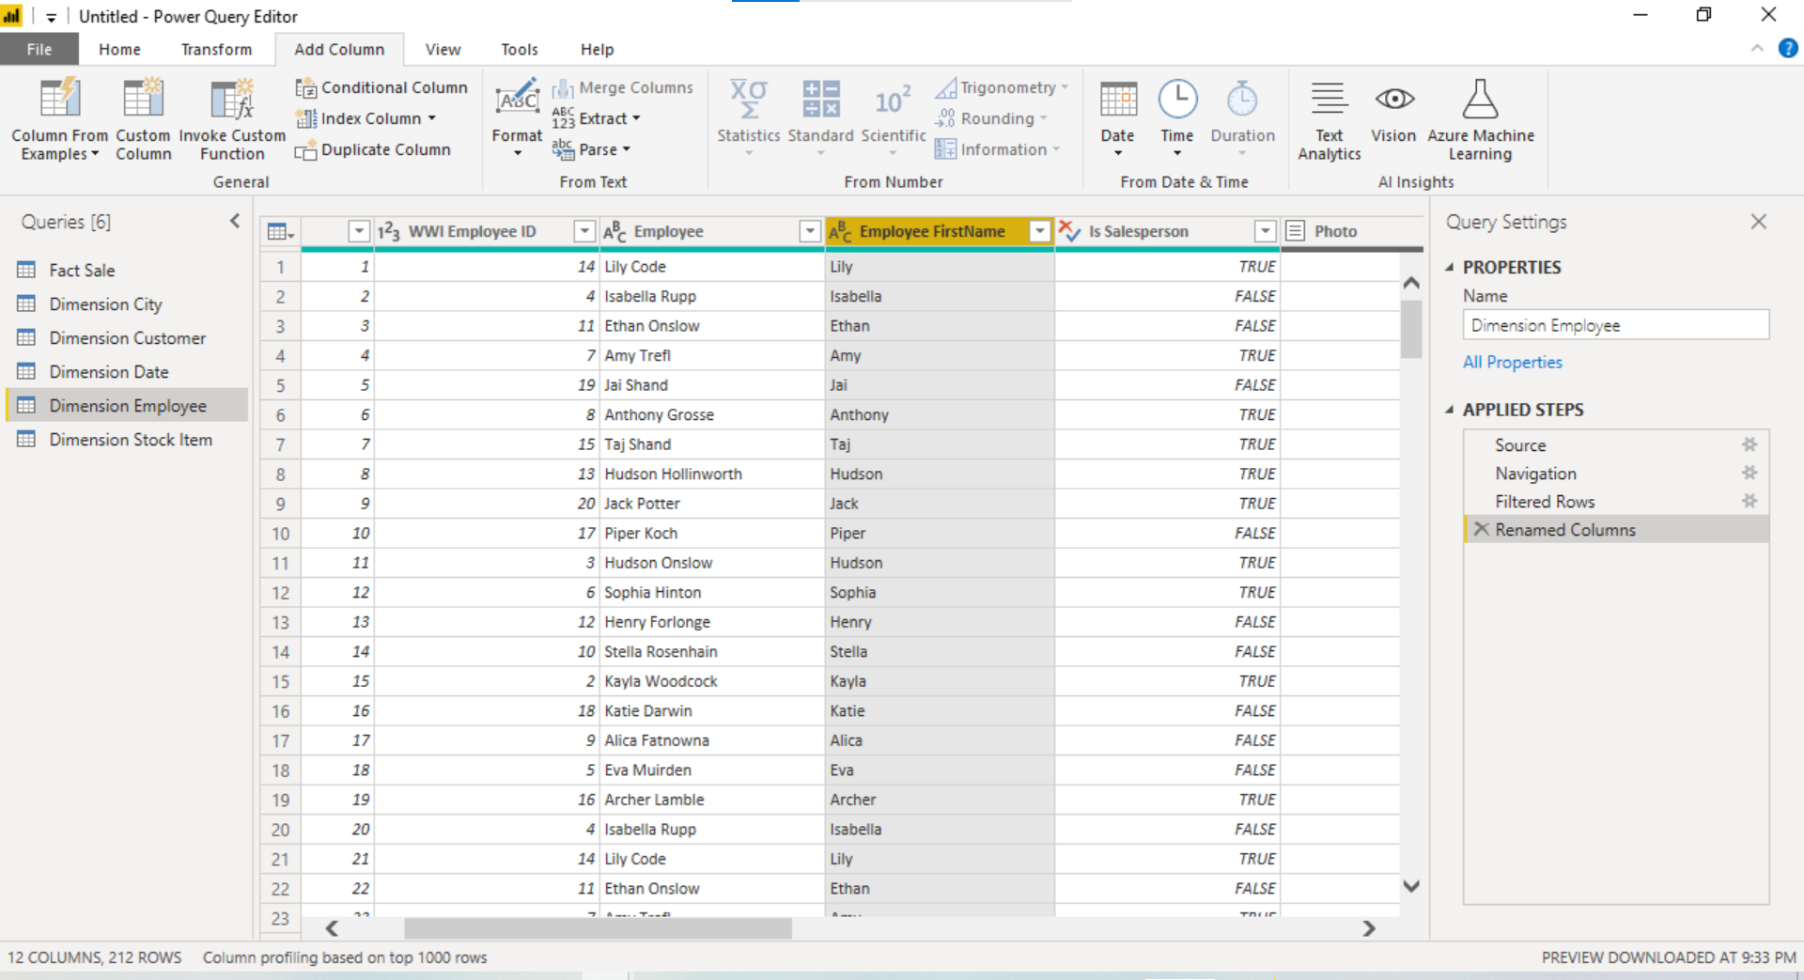

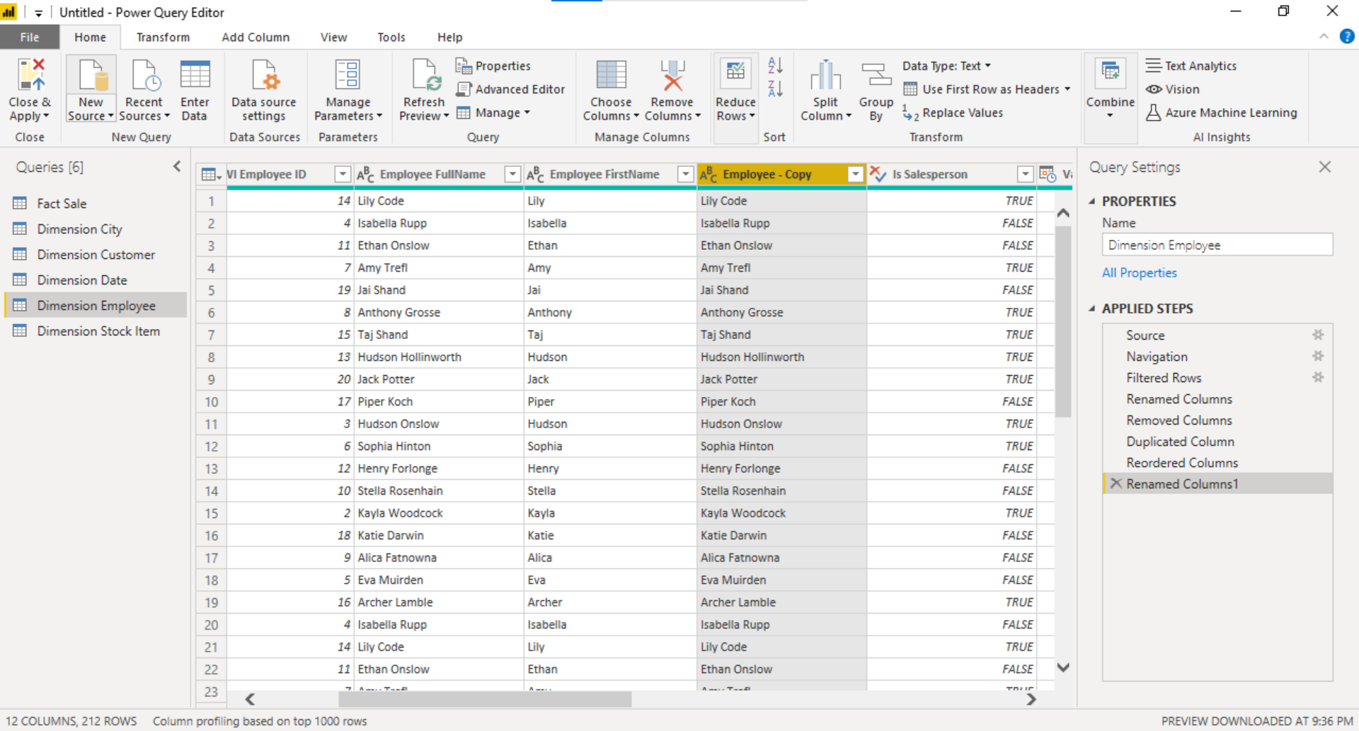

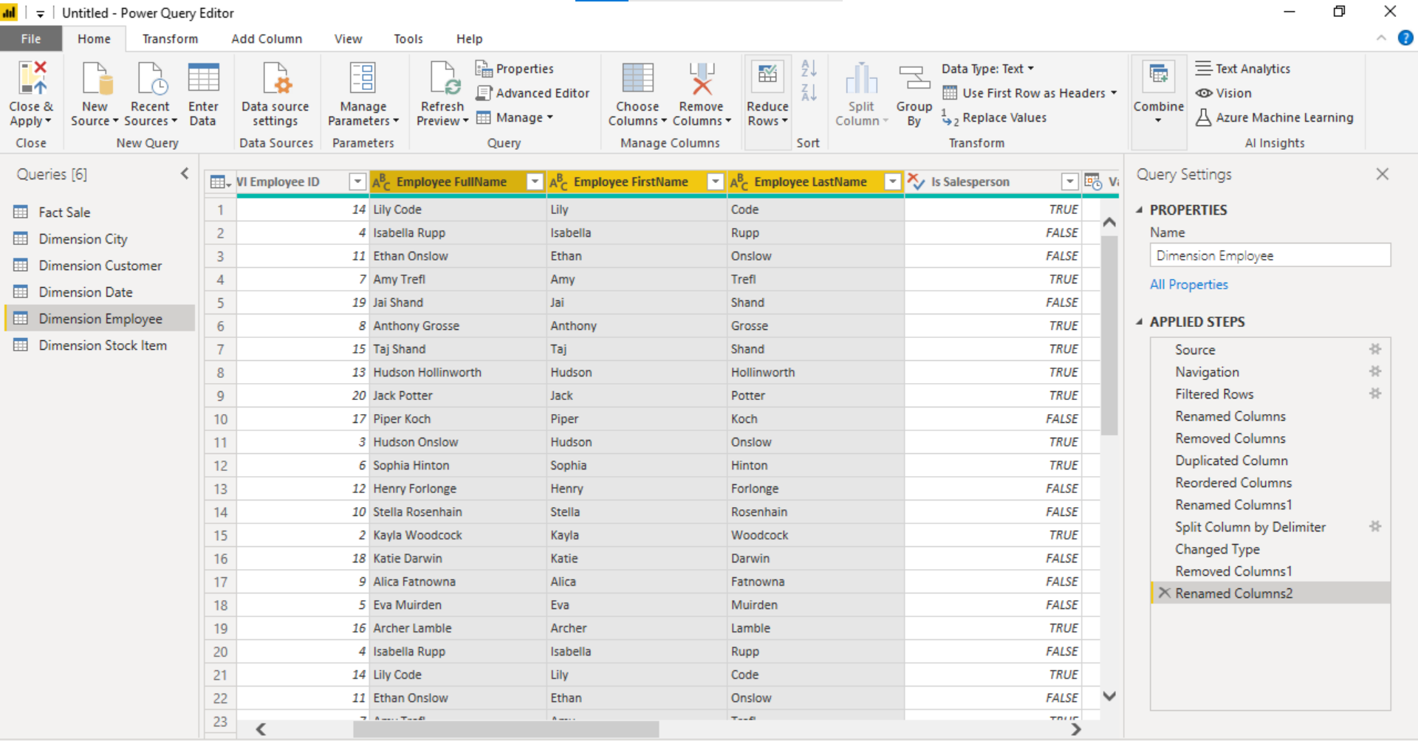

Removed Photo columns as it has all null values.

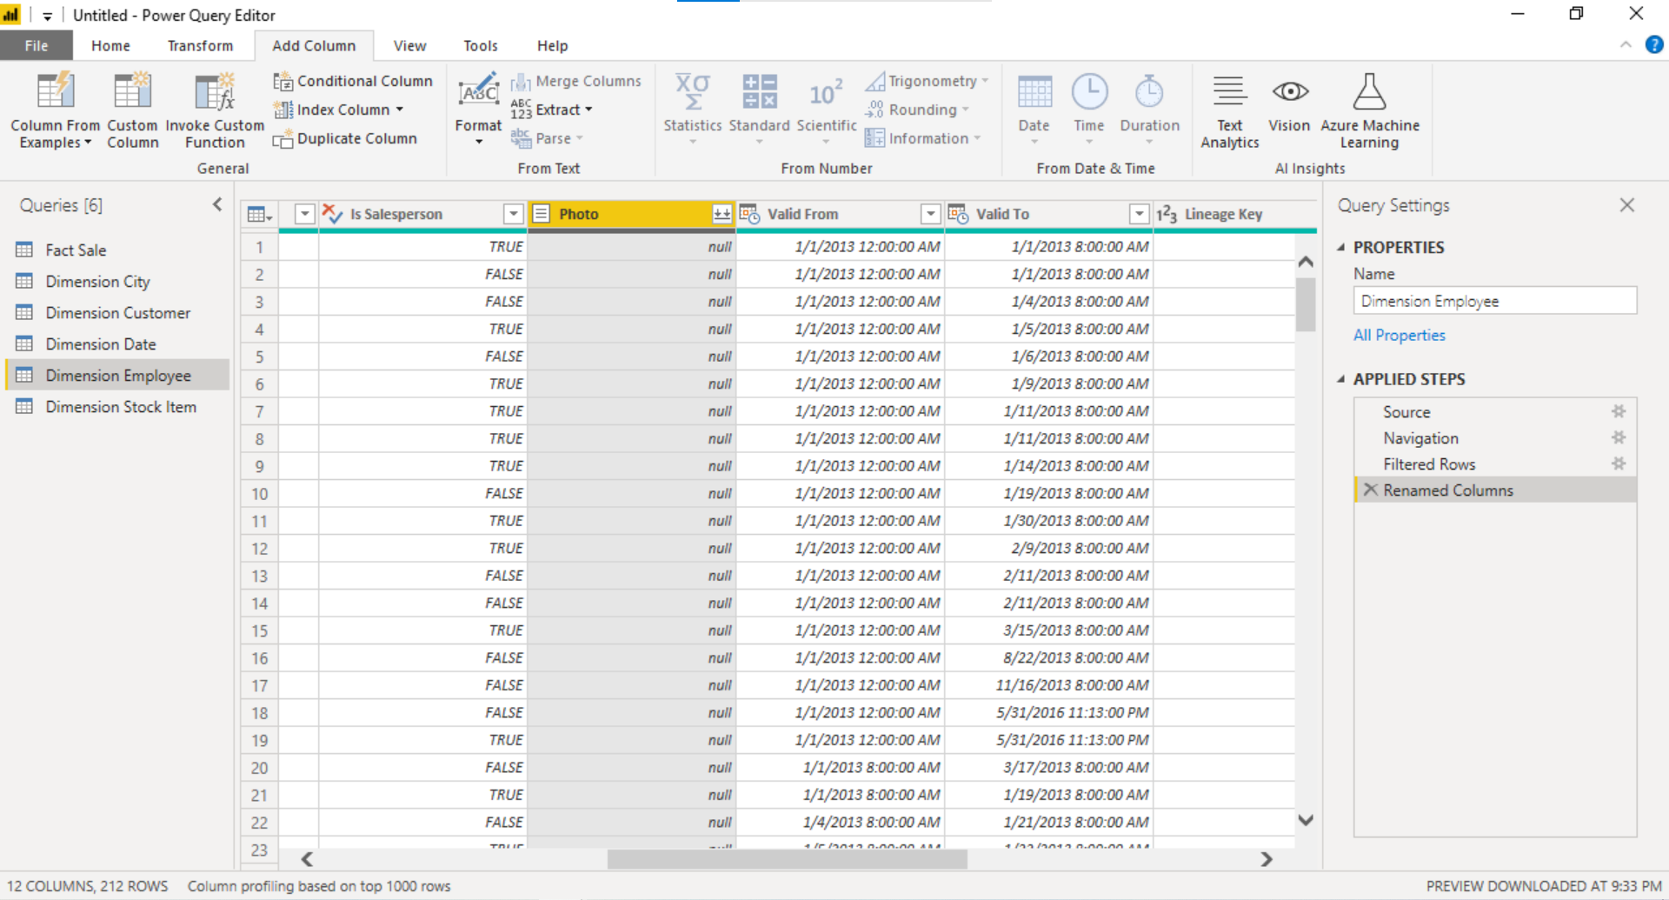

Replace the values in Brand column as it has N/A which means non branded. So, replacing N/A by nonbranded.

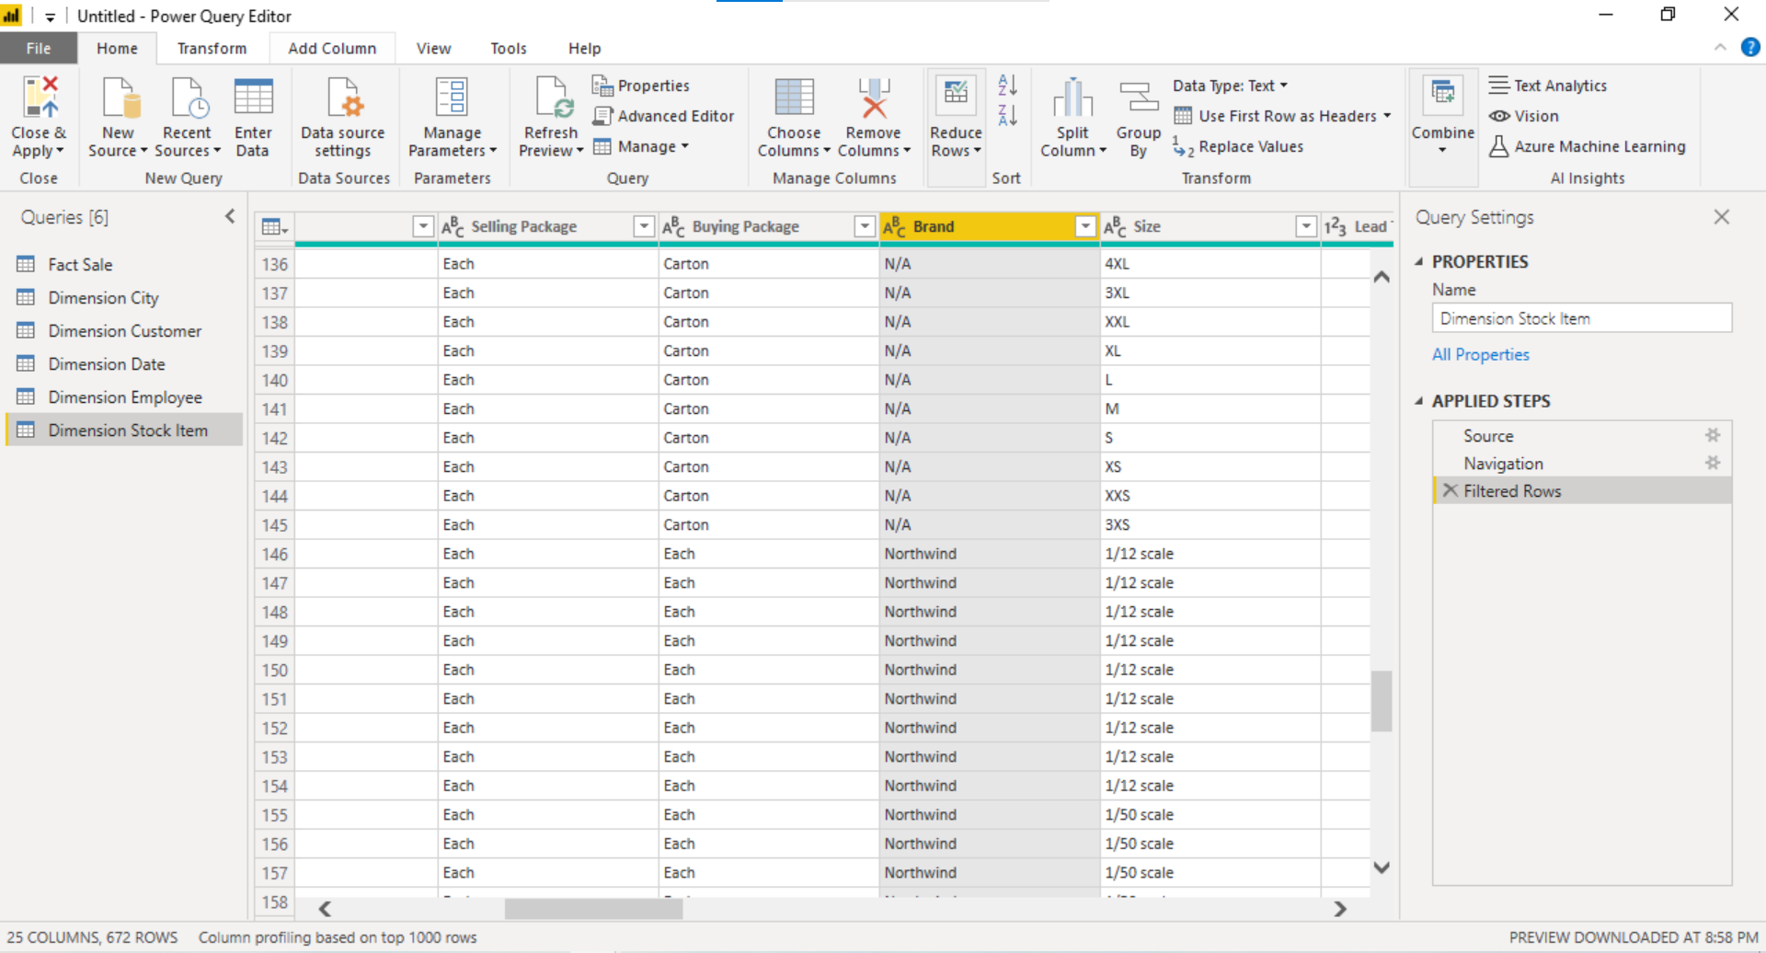

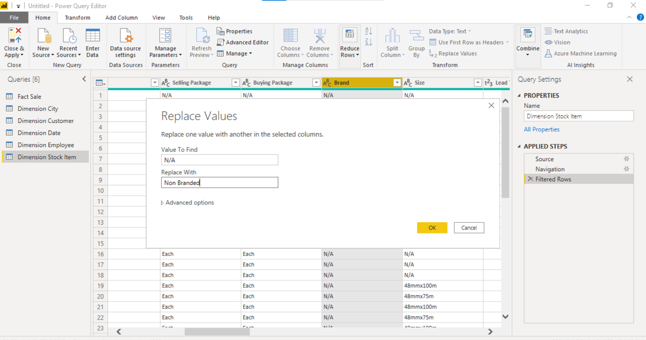

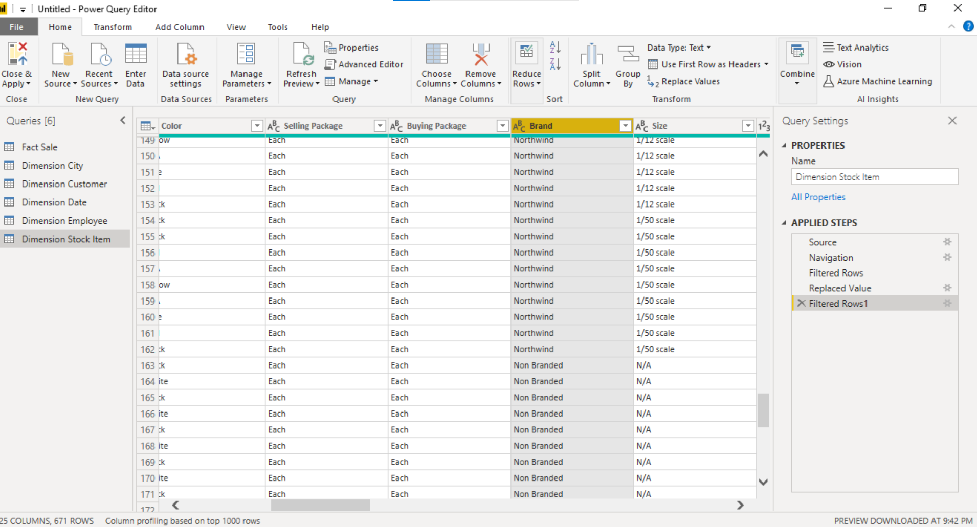

Removed unknown stock items.

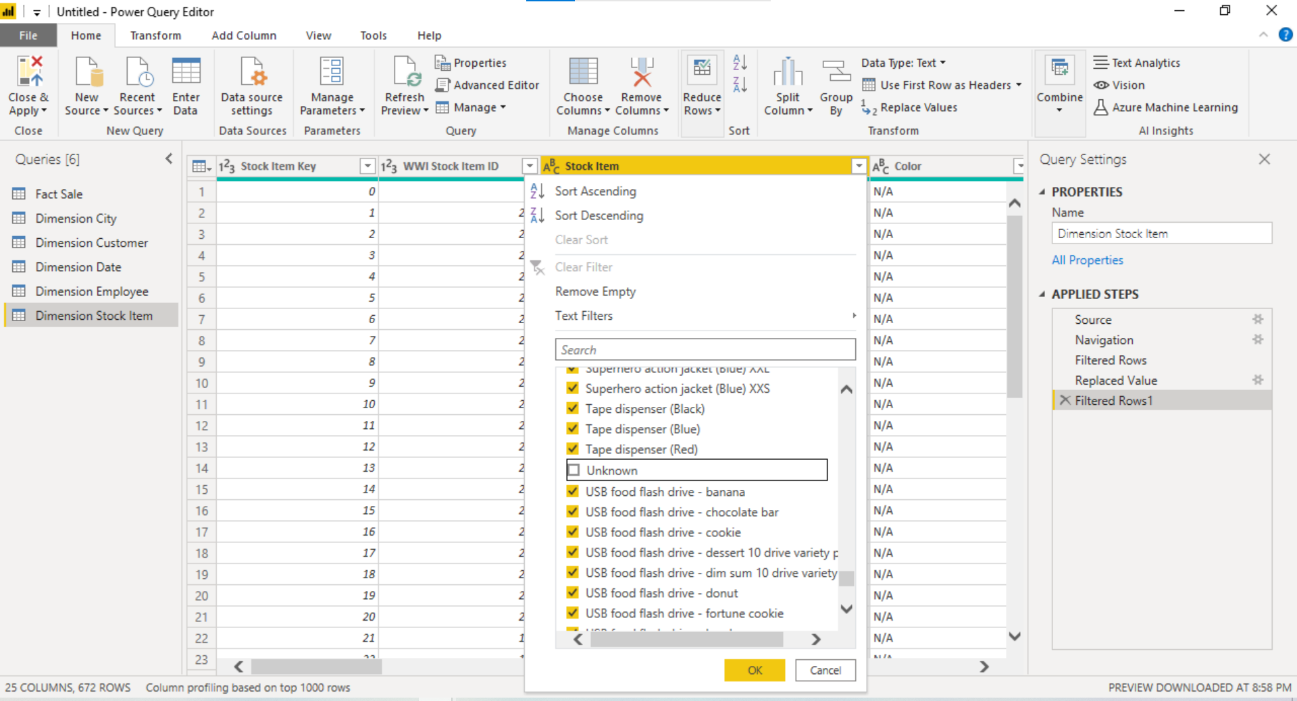

Date table is Marked.

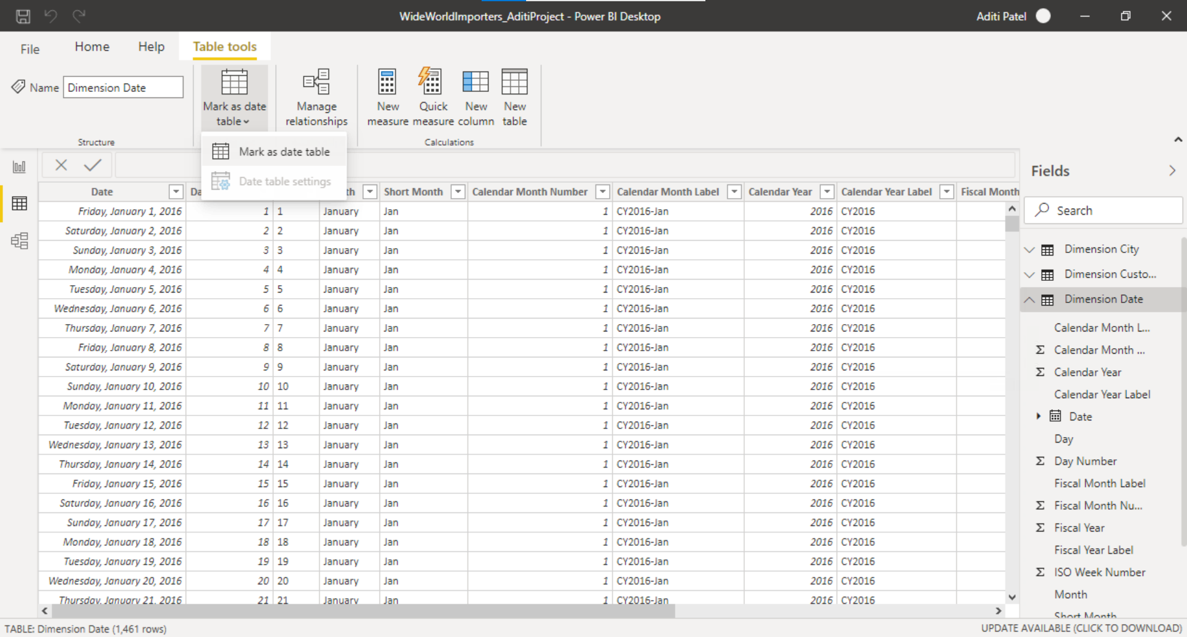

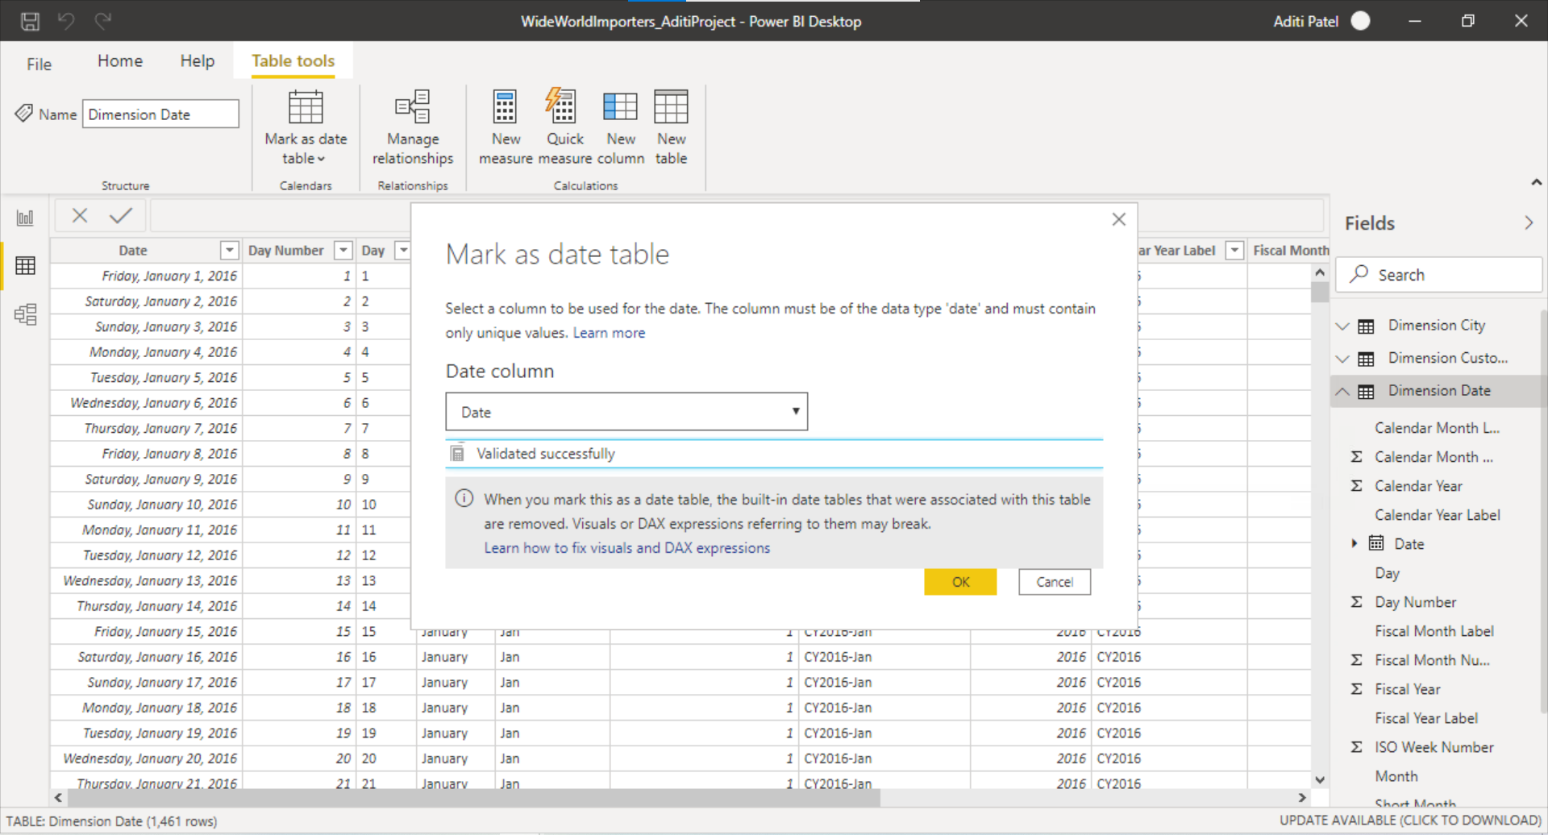

Week Day = FORMAT('Dimension Date'[Date],"dddd")

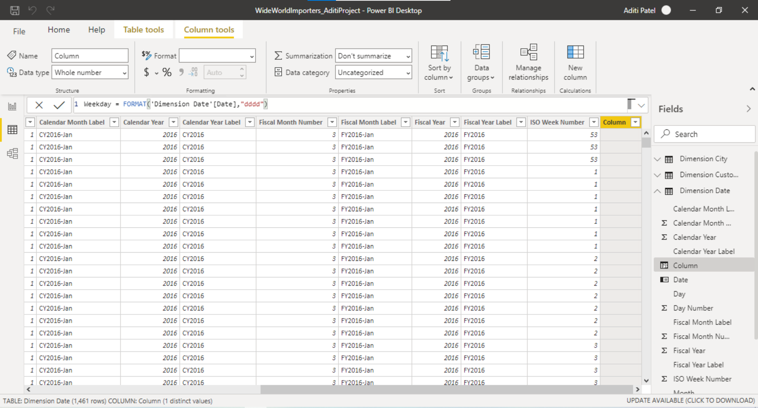

New column = Week Day is created using Format function by using below formula below:

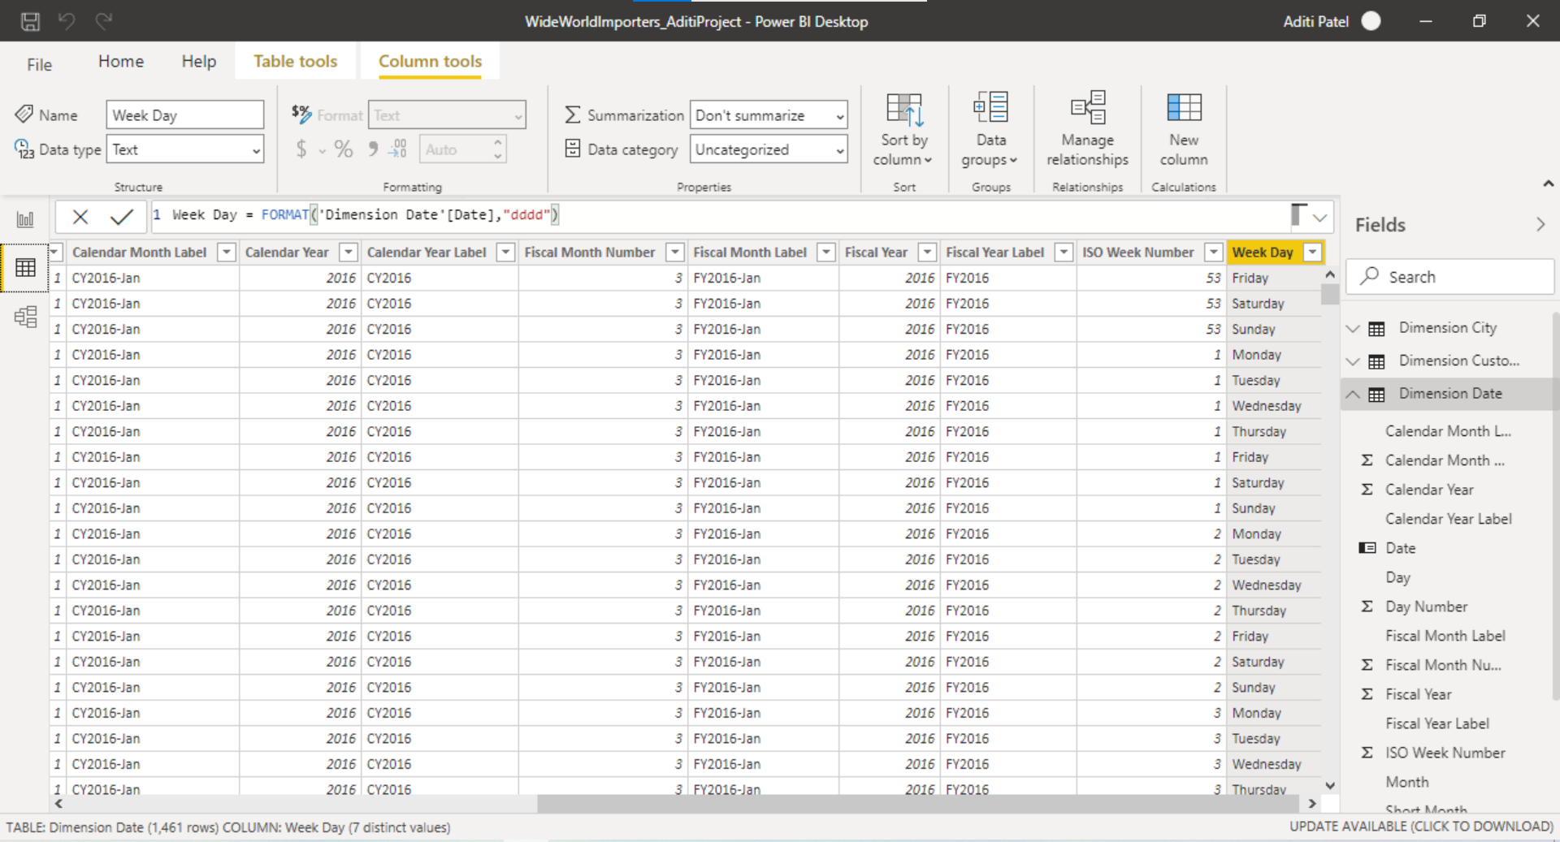

Created WeekDayOrder column to arrange week day into chronological order.

WeekDayOrder = WEEKDAY('Dimension Date'[Date],1)

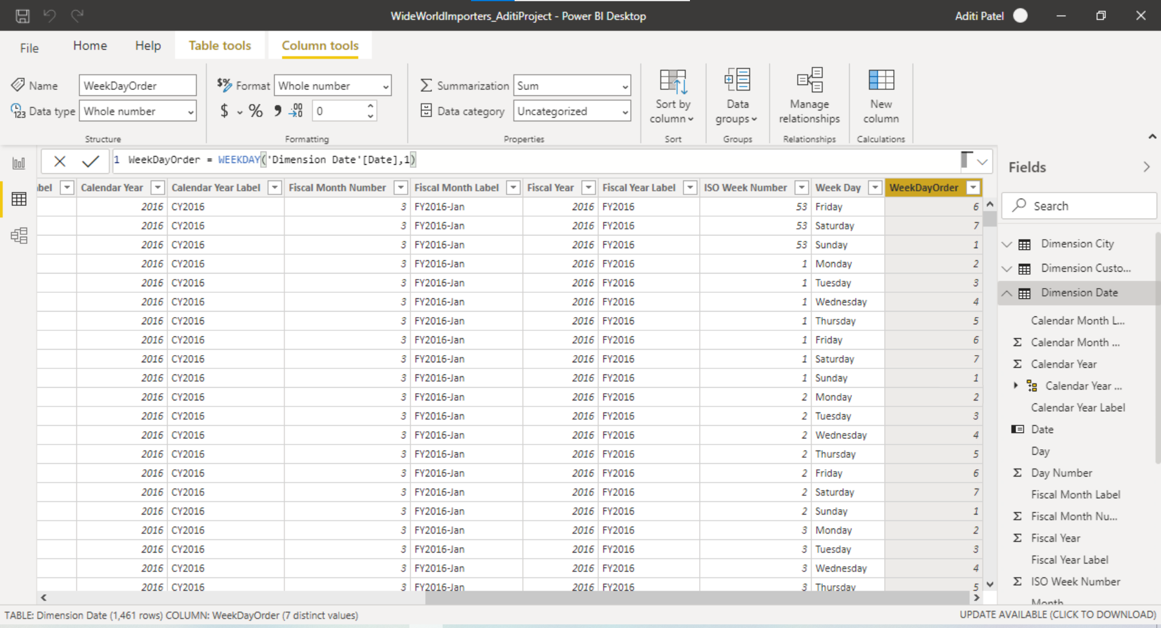

Sort by weekday order to display weekdays in chronological order.

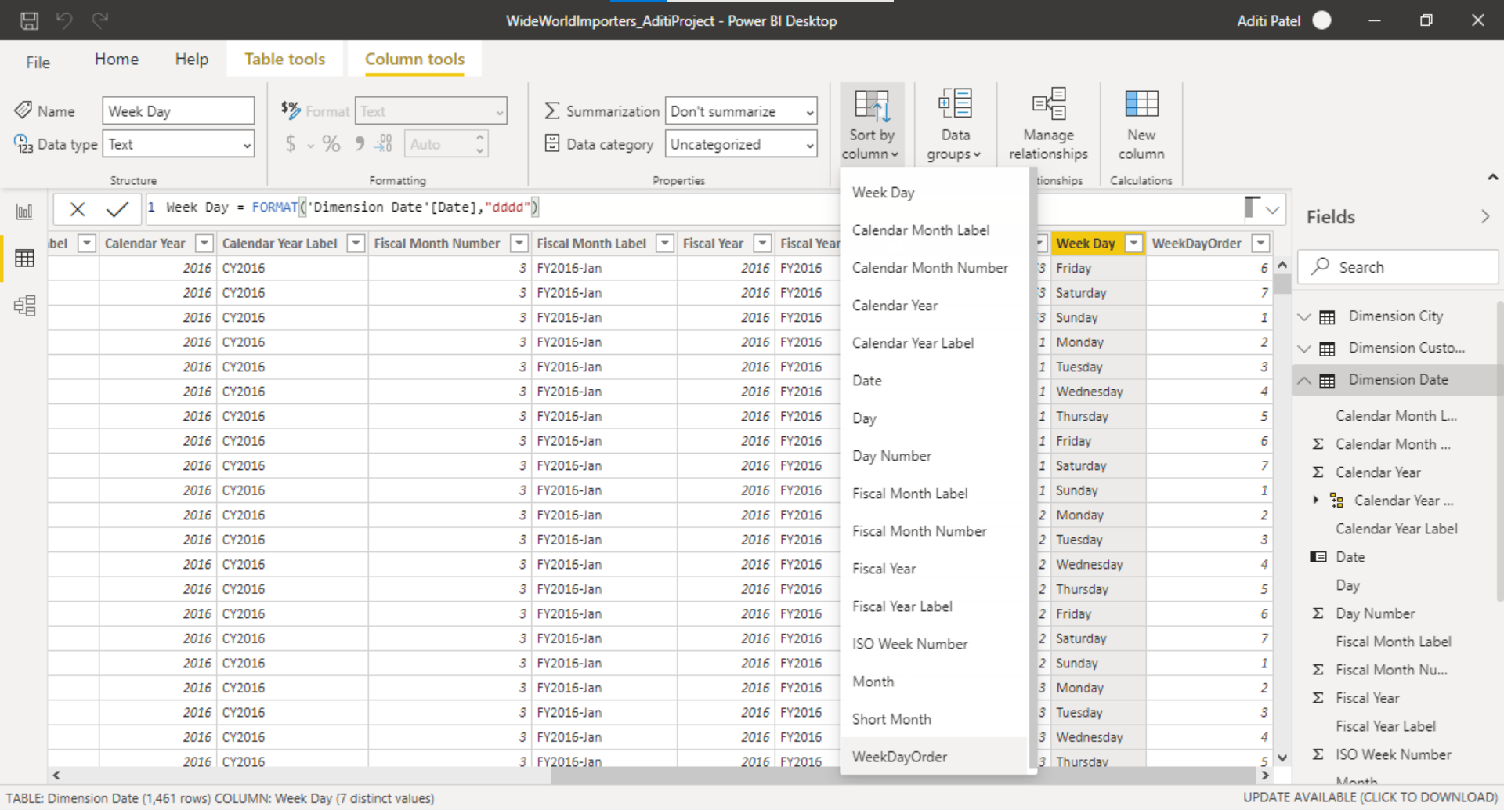

Added few more tables for analysis.

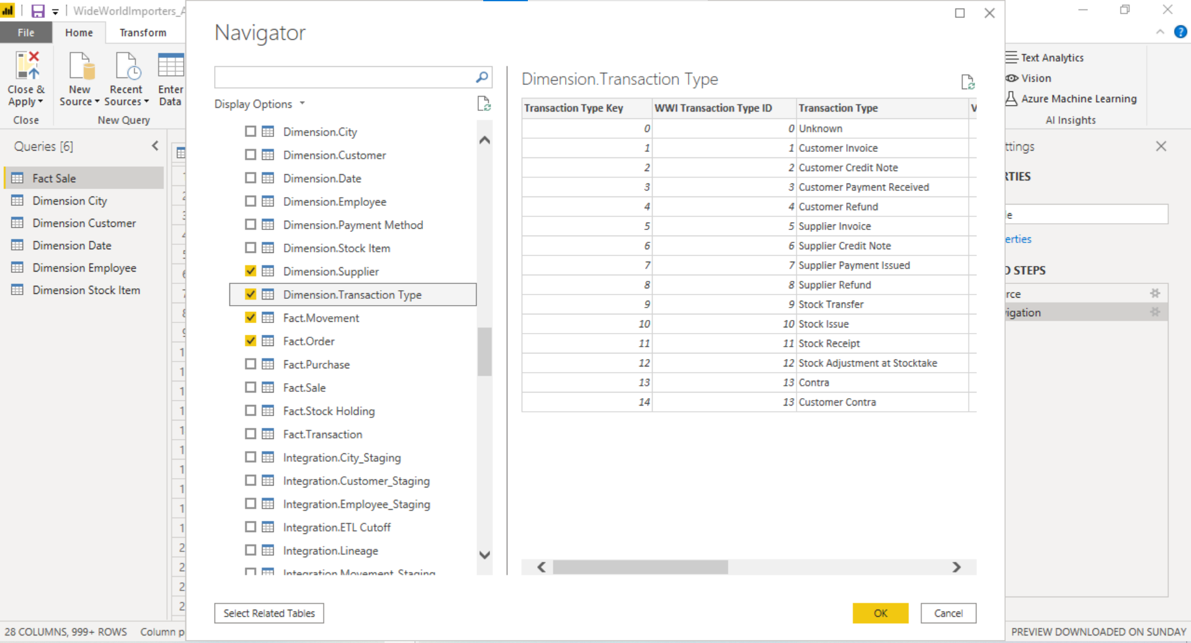

Added conditional column: Incoming stock from Quantity column

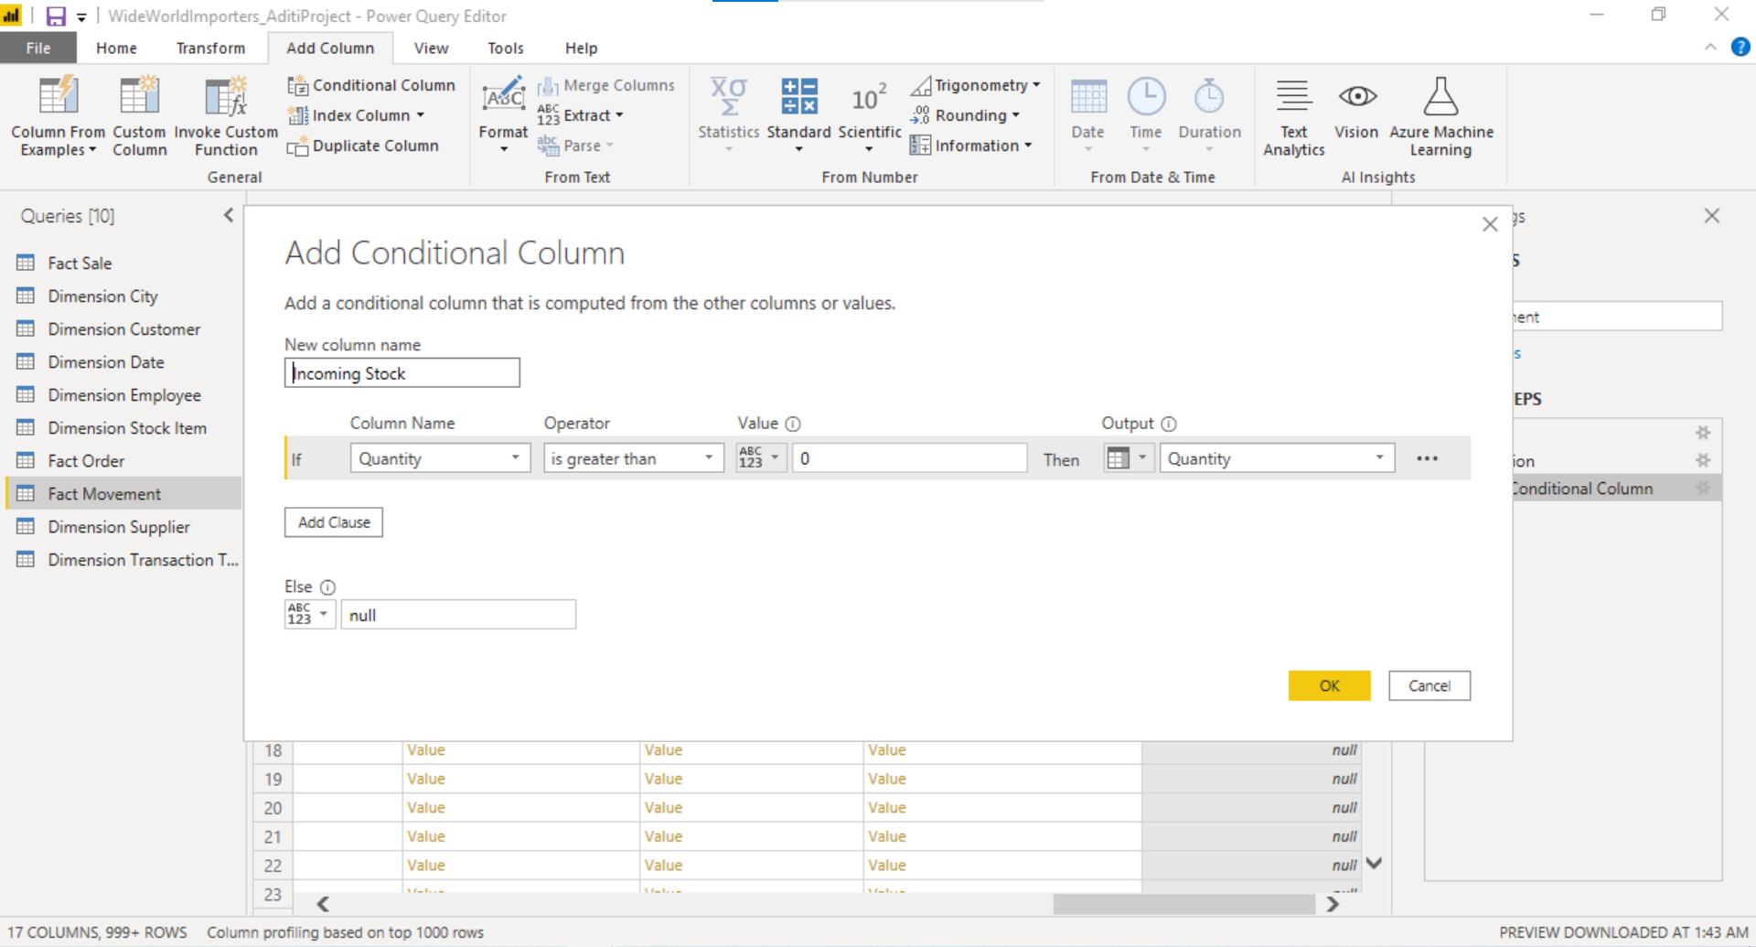

Added conditional column: Outgoing stock from Quantity column

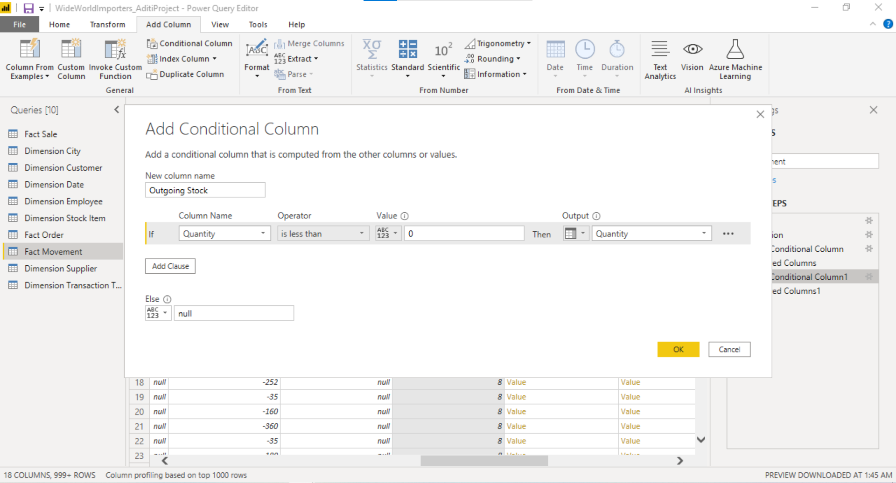

Quantity column has positive values and negative values. Positive values define incoming stocks and negative values define outgoing stocks.

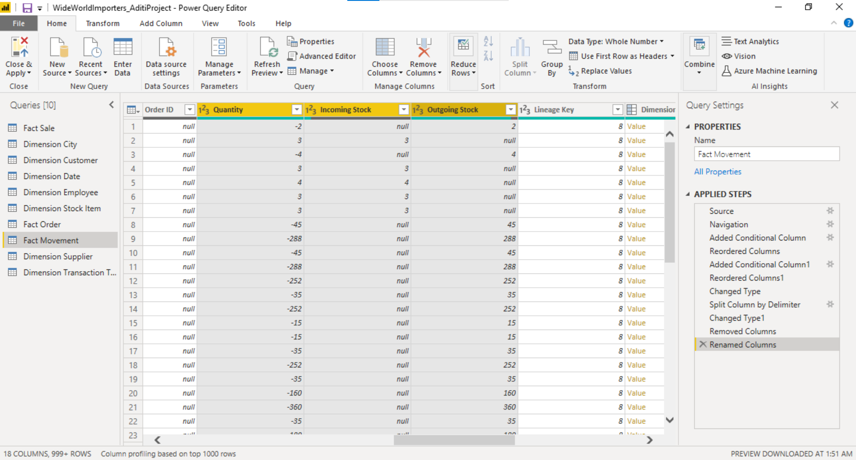

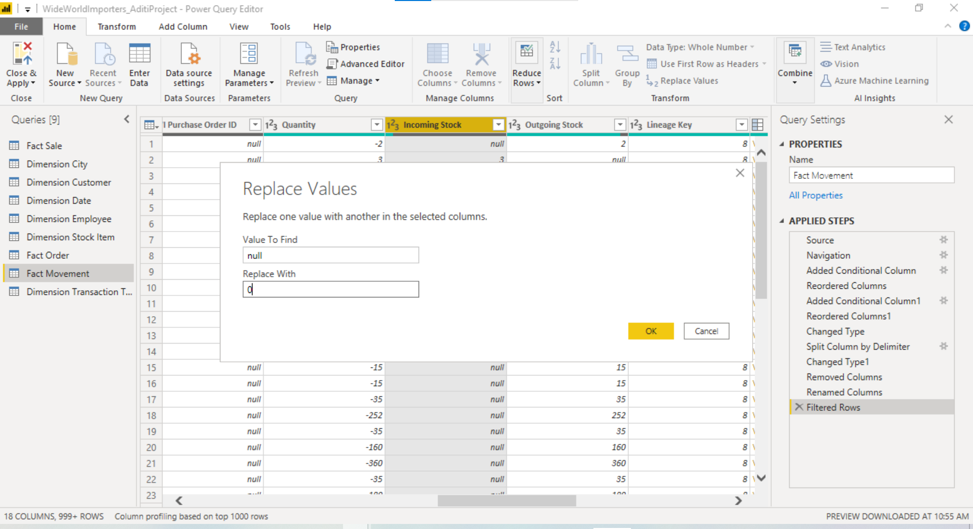

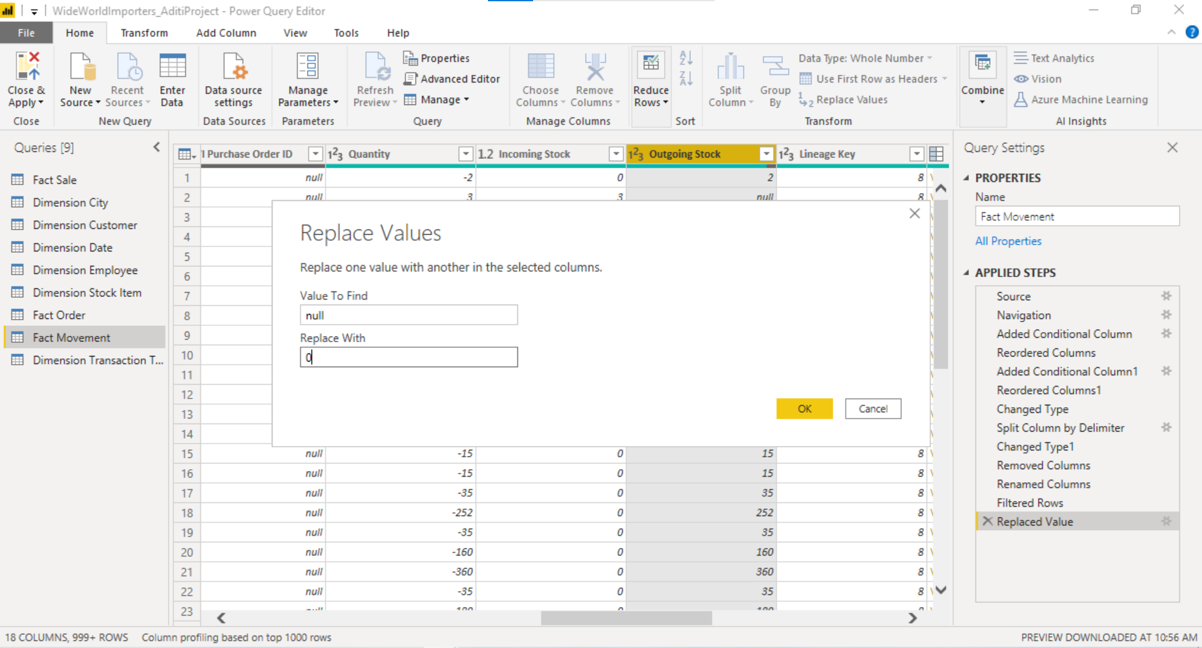

Added Measure: Total Sales which include sum of total sales including tax.

Total Sales = SUM('Fact Sale'[Total Including Tax])

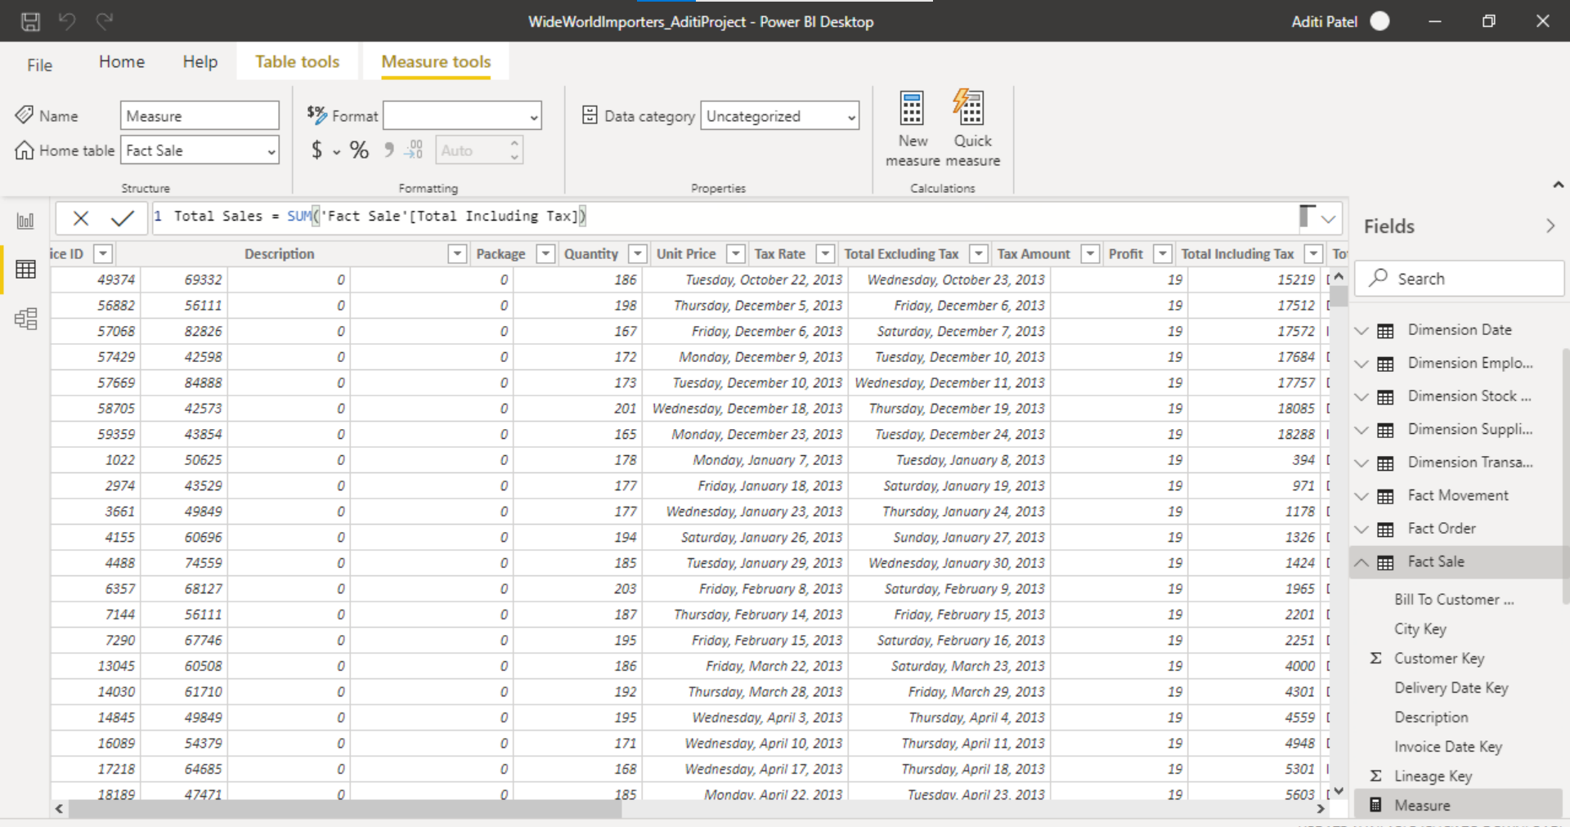

Finalized tables for analysis

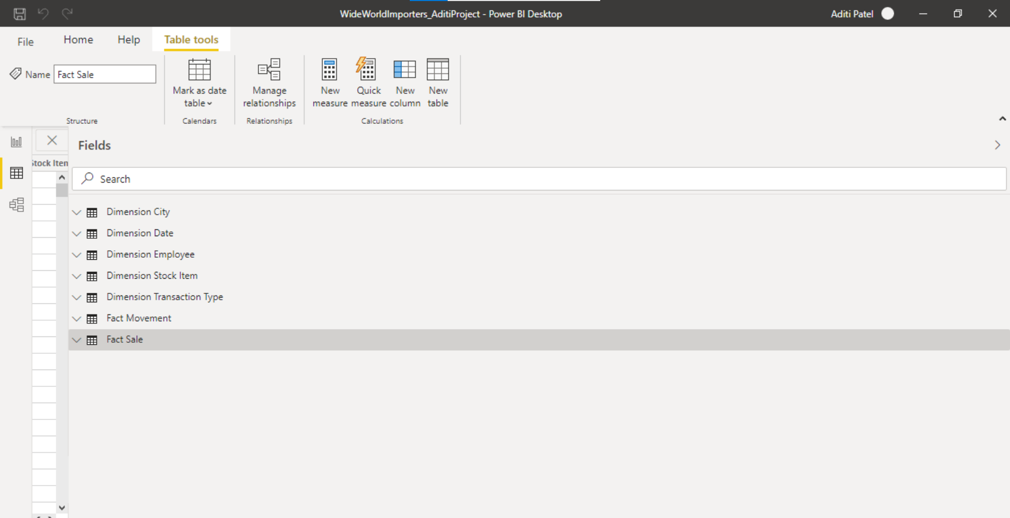

**DATA MODELING:**

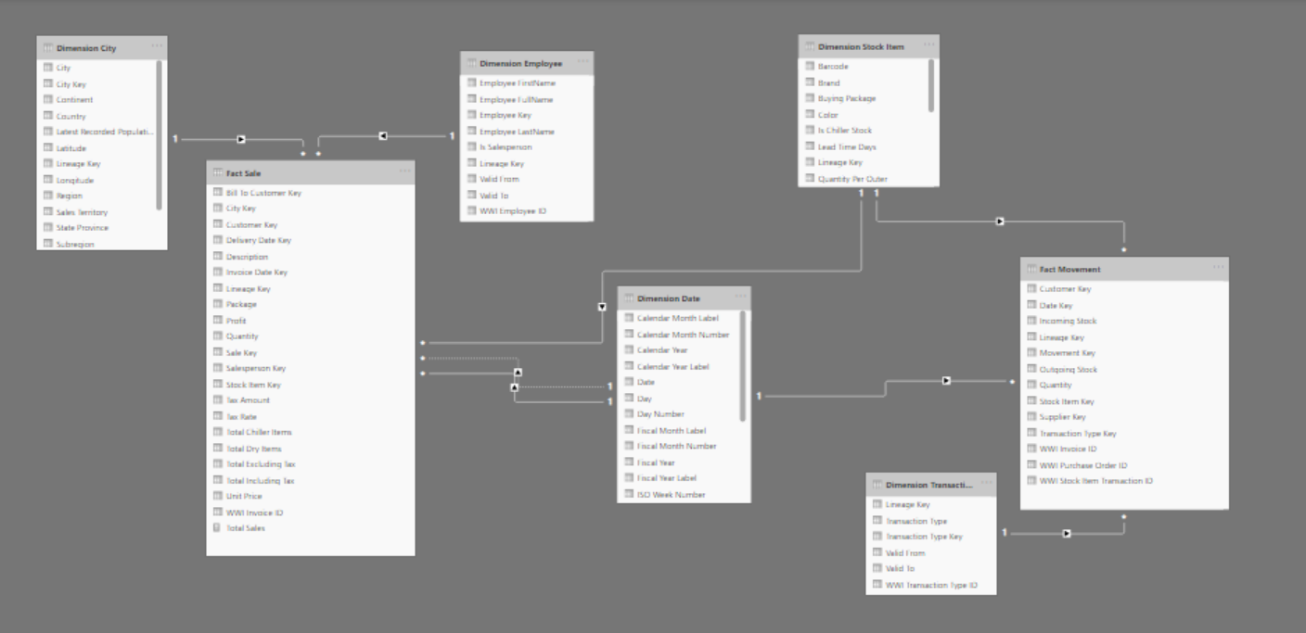

**ANALYSIS AND VISUALIZATION:**

**Filled Map** shows the location included in dataset with the 9 sales territories of North America in USA.

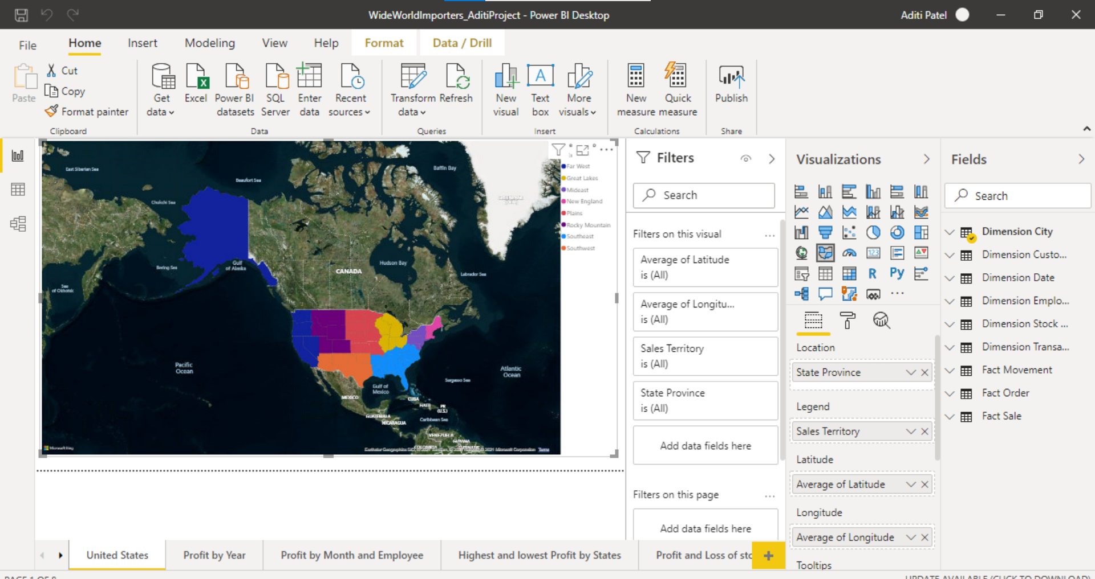

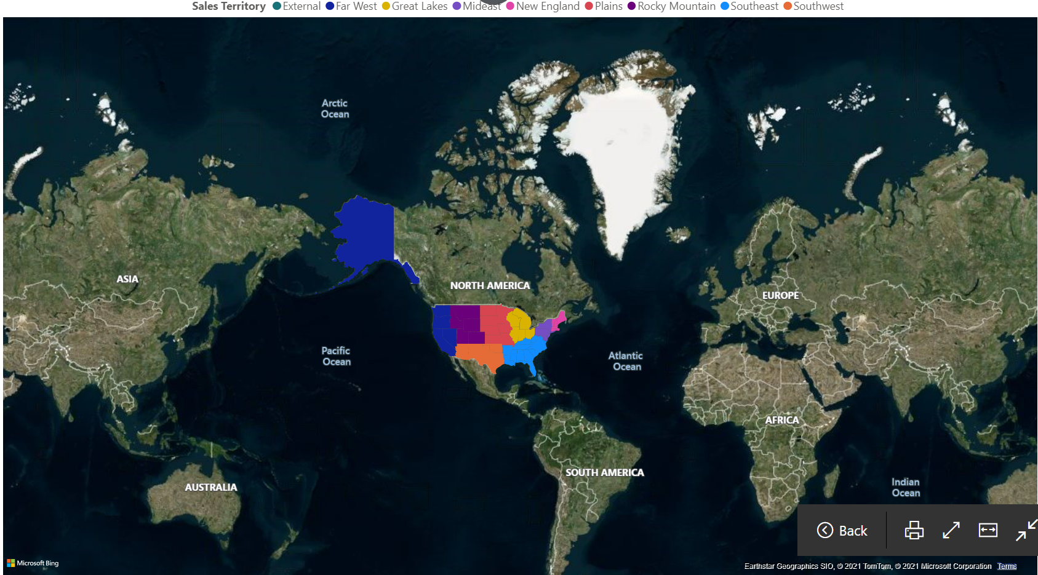

**Line Chart:** Shows profit based on year and concluded that dataset has data from January 2013 to May 2016

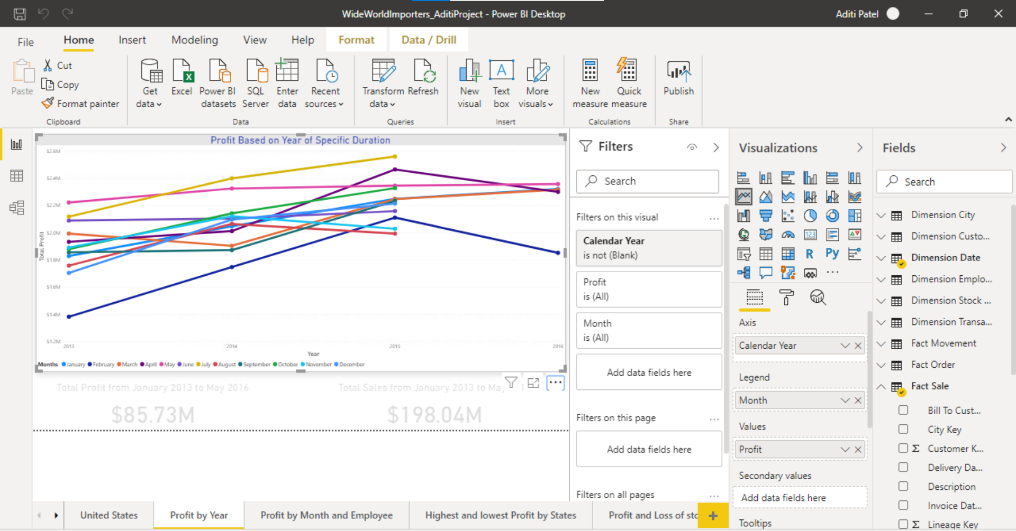

**Profit Card:** shows the Total profit from January 2013 to May 2016

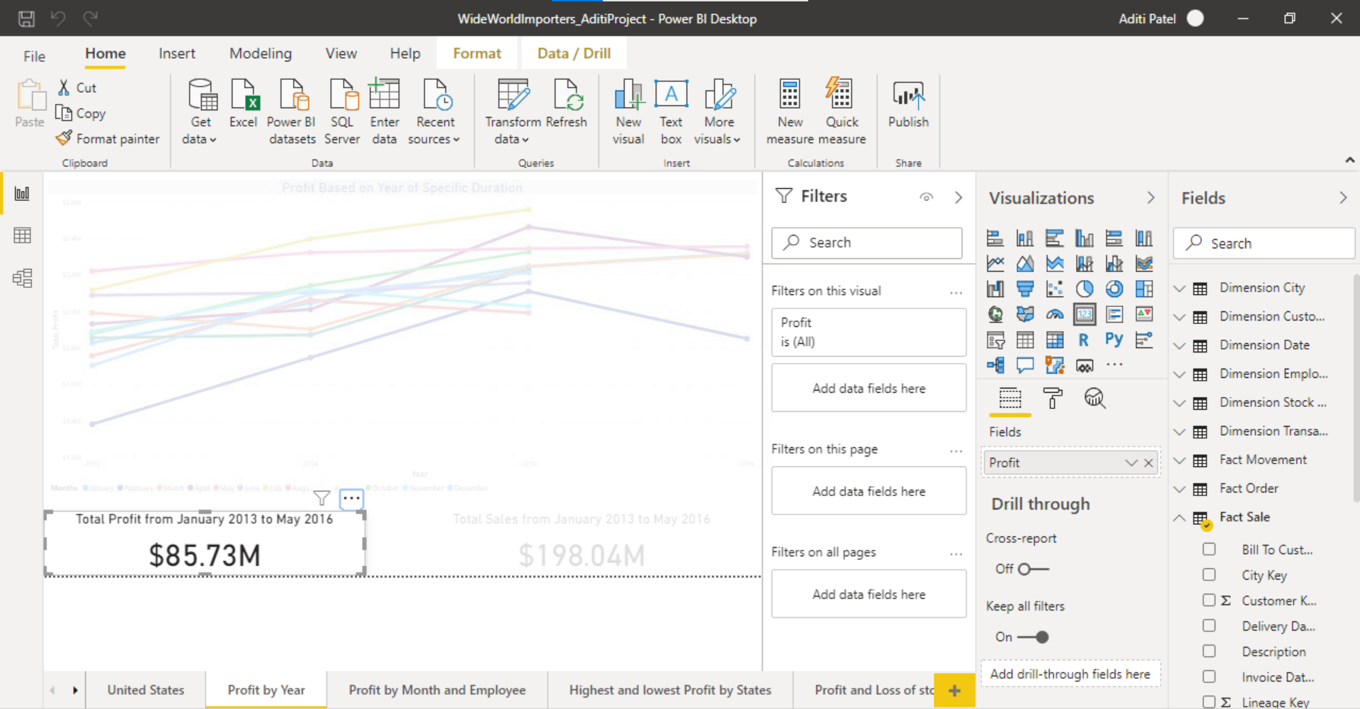

**Sales Card:** shows the total sales from January 2013 to May 2016

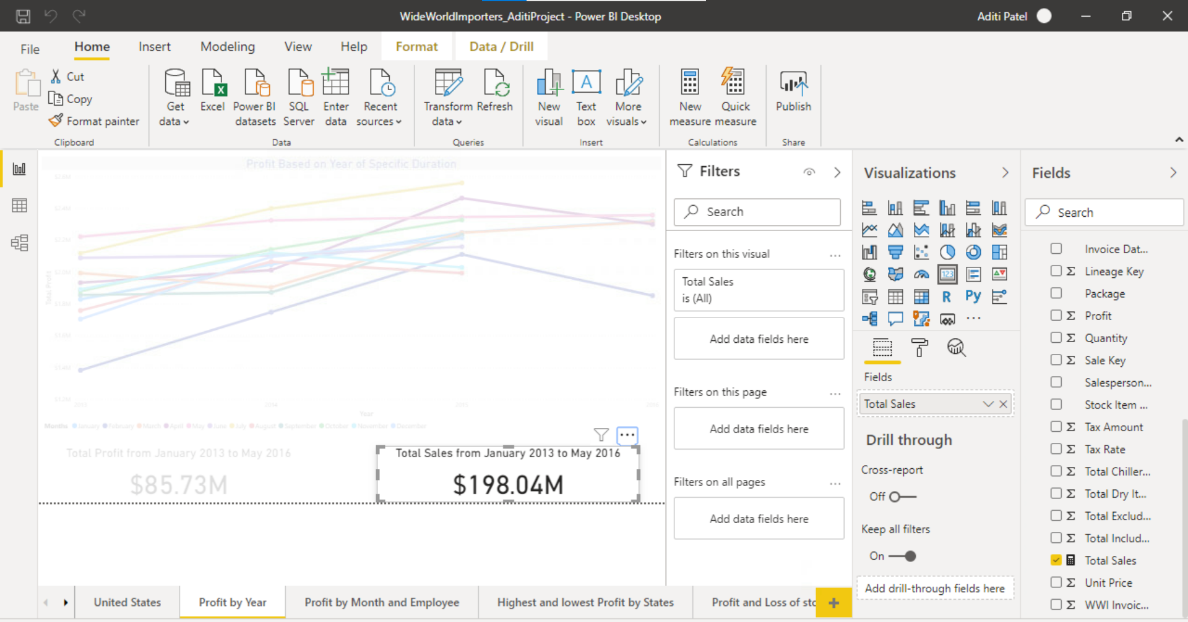

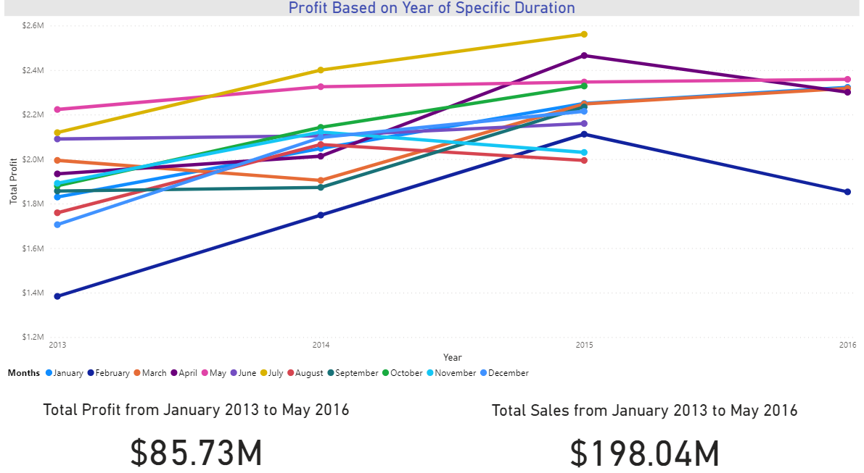

**Clustered Column Chart**: show the productivity of employees by month. Sorted in descending order which indicates May month has highest Profit and Archer Lamble is the most productive employee in May but overall Hudson Onslow has the highest profit among all employees.

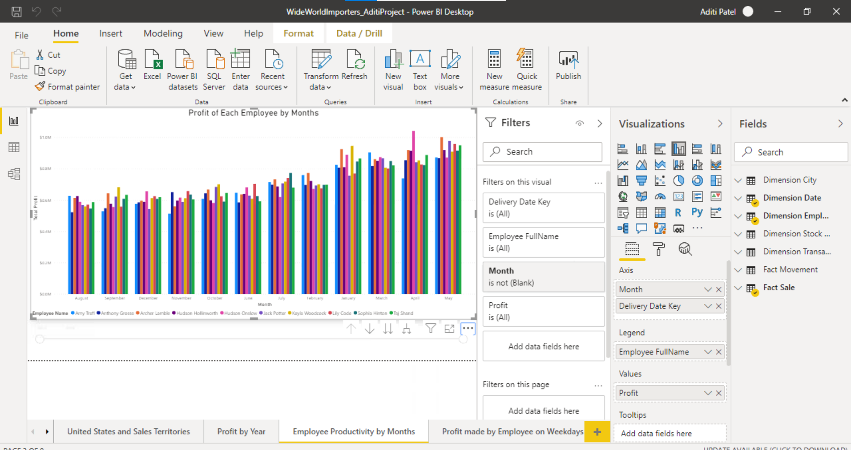

Added Slicer to analysis by year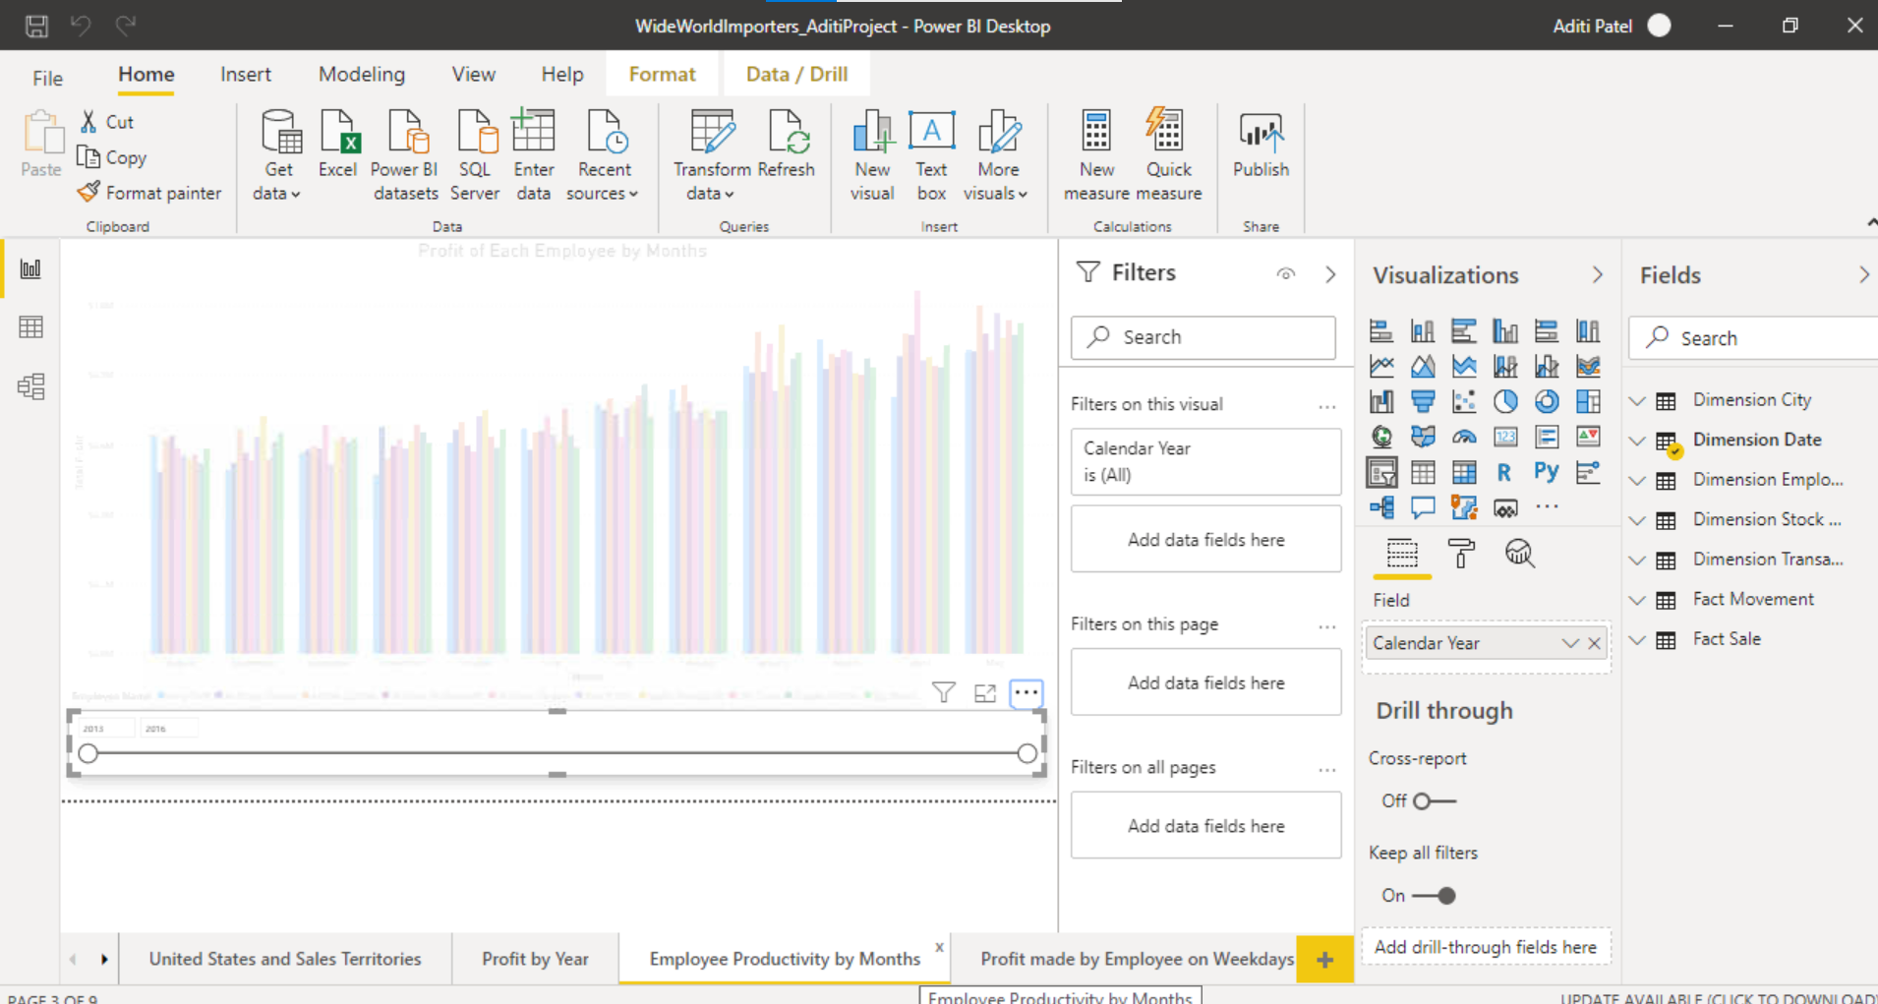

**Line Chart:** shows profit made by each employee based on weekdays and found that Archer Lamble has made highest profit but found that Hudson Hollinworth is top on weekends (Saturday and Sunday). So, it seems like Hudson Hollinworth must be working full hours during weekends rather than weekdays.

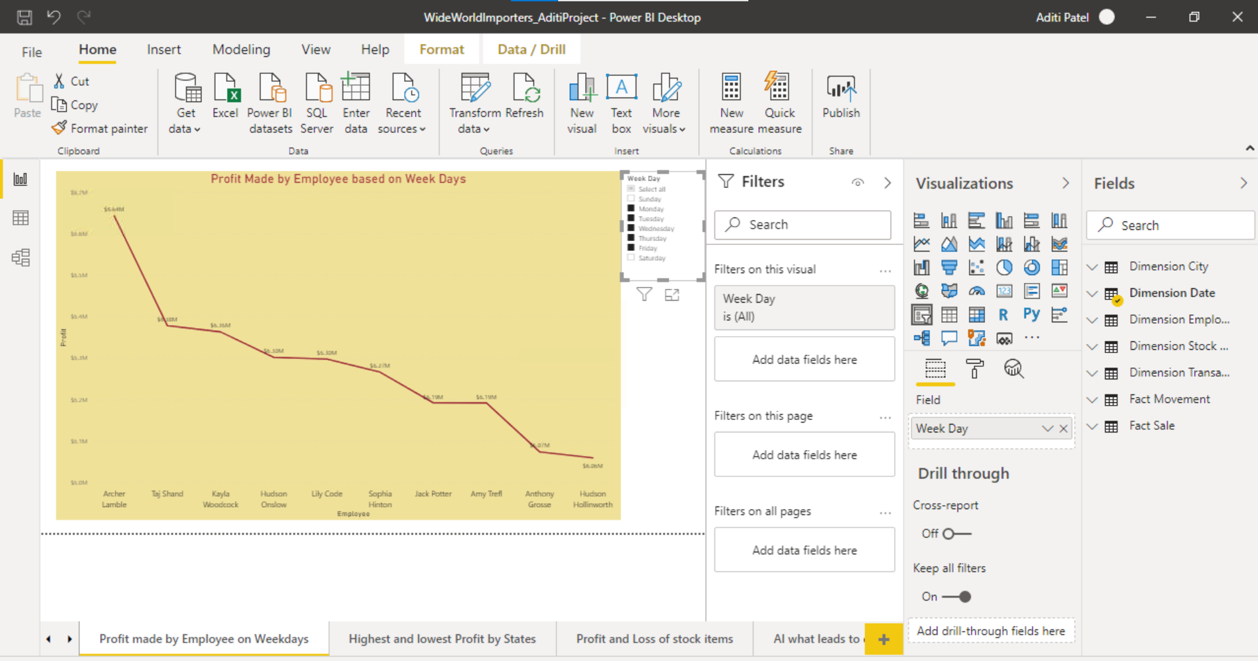

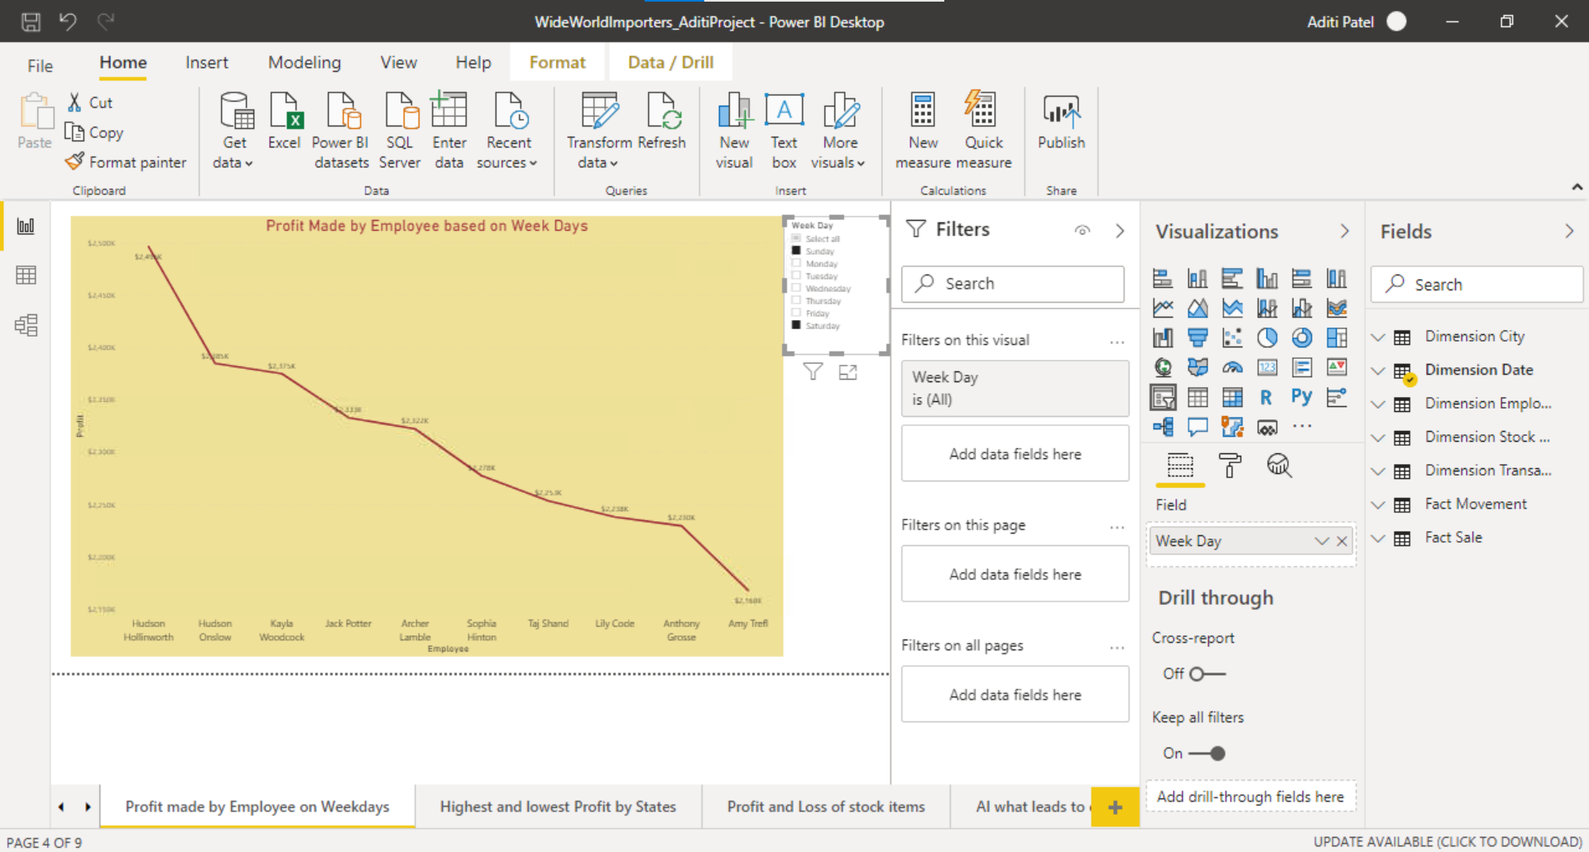

**Pie Chart:** shows top 10 states based on Profit and Texas is the topmost state. Might be because of populated state or may be the productive employee like Hudson Onslow belongs to the Texas.

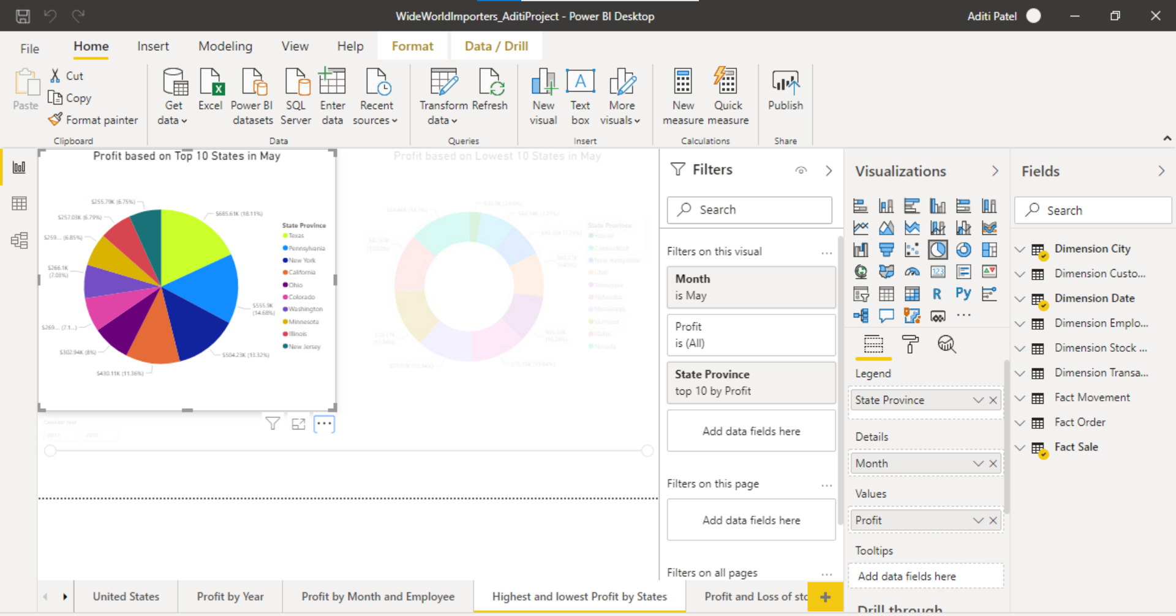

**Donut Chart:** shows the bottom 10 states which has lowest profit and found Hawaii is the lowest profitable state. Might be because of less population of may be the shortage of employee or incoming stocks.

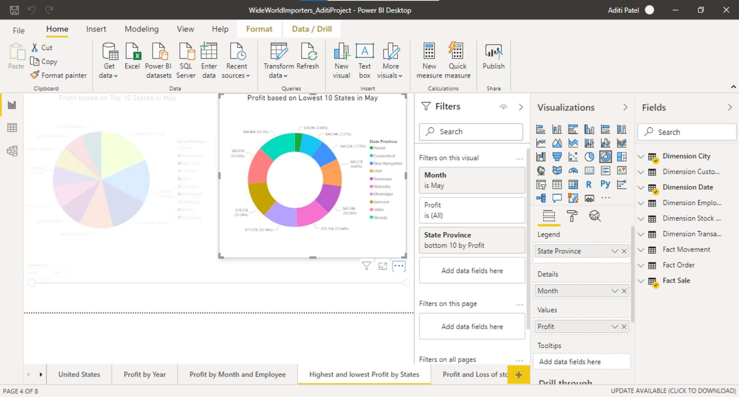

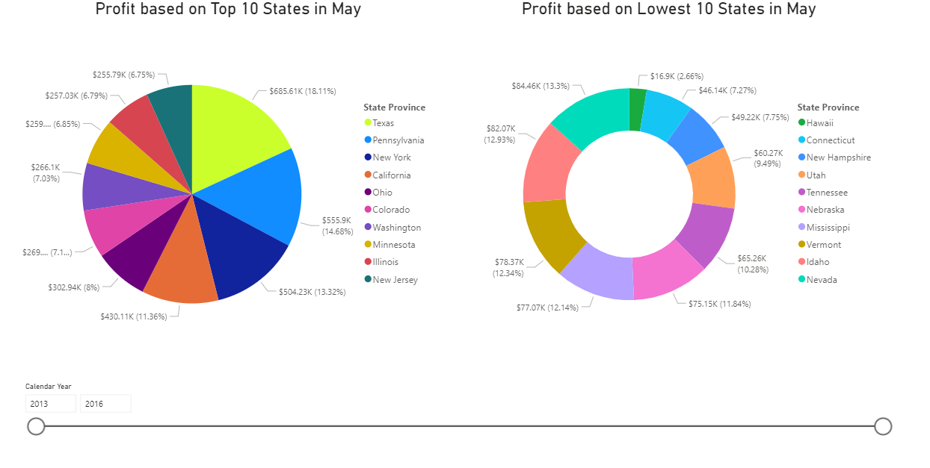

**Stacked Bar Chart**: shows top 20 stock items by Profit and its clearly visible that profit suddenly dropped after the 7th item it may be because of shortage of stocks

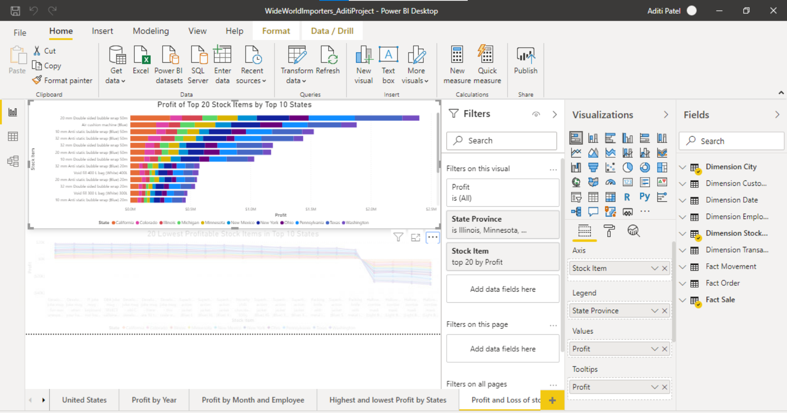

**Stacked Area chart:** show lowest 20 profitable items and it has been noticed that few item has negative profit that mean those items does not make any profit instead those are the items which are in loss.

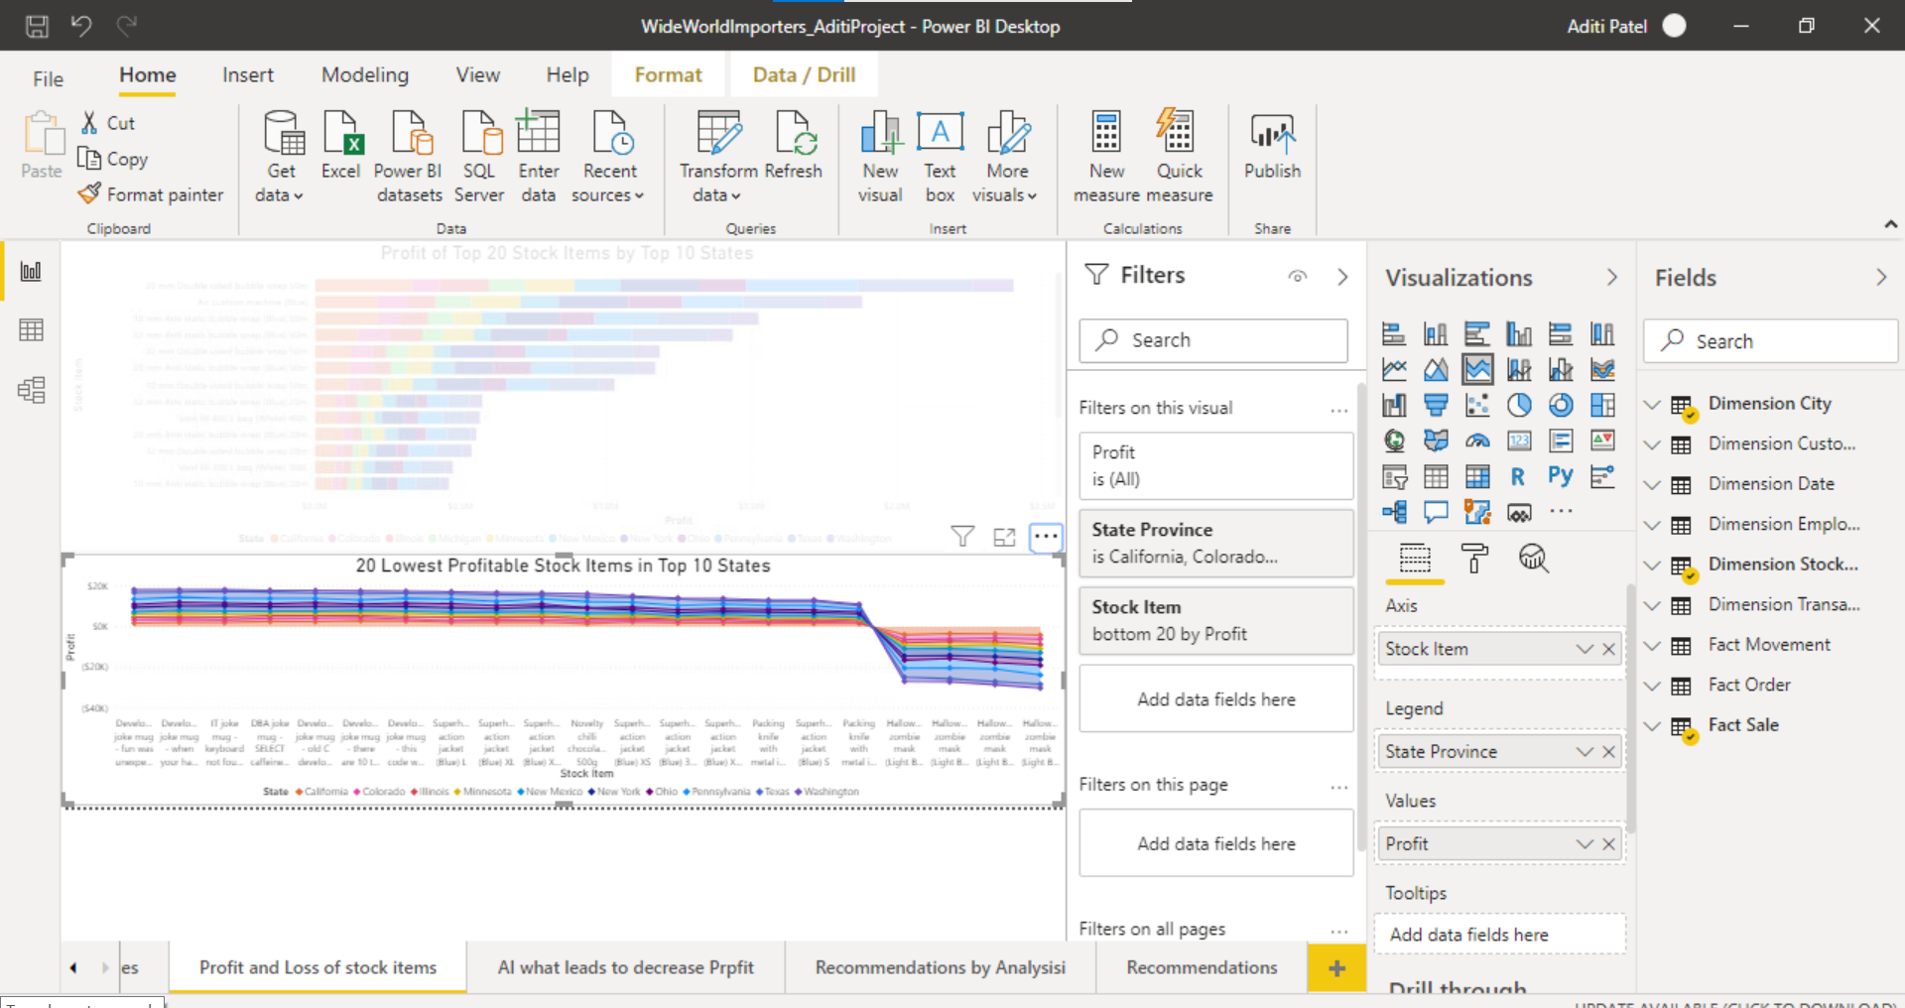

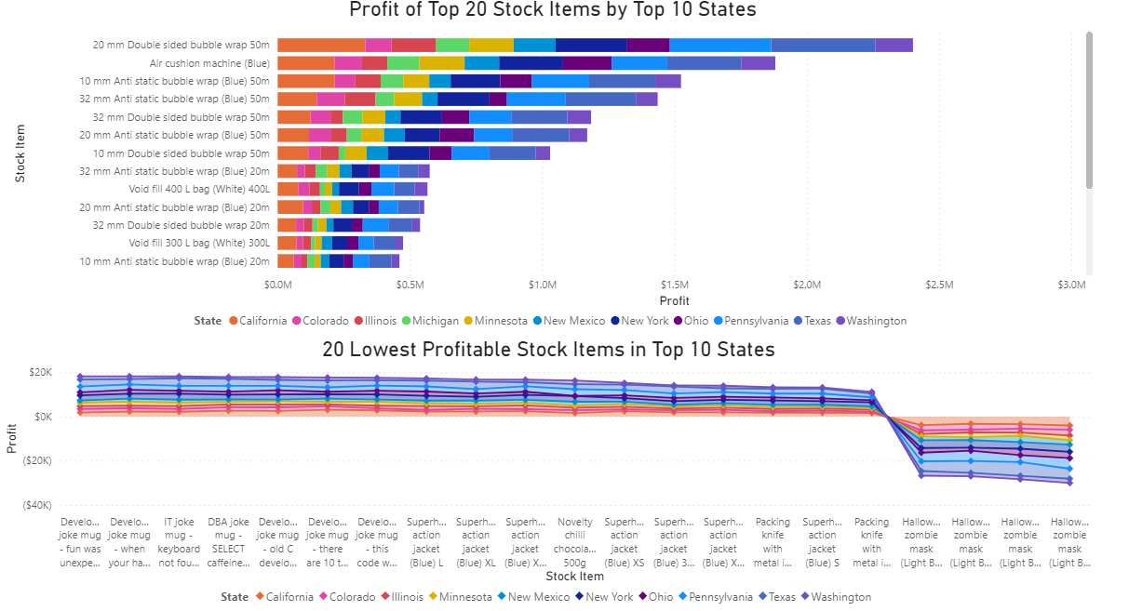

**Key influencers:** It’s an Artificial intelligence technique to predict what factors influences profit to drop above chart’s items? By taking unit price and quantity into consideration, Low unit price and low quantity leads to loss and also “Low unit price, more quantity (rare case)” might be in loss.

The chances of profit to decrease at Unit Price 12.5-13 is more

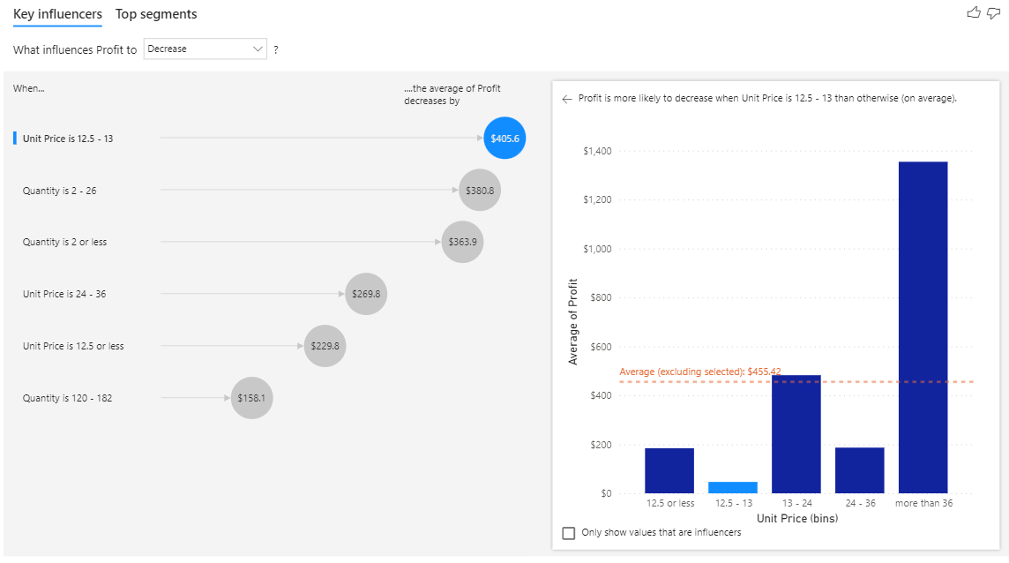Five segments which leads profit to be low.

Segment 1: If Quantity is <=2 but unit price is high and If quantity is >=120 but unit price is low in both case profit is more likely to be low.

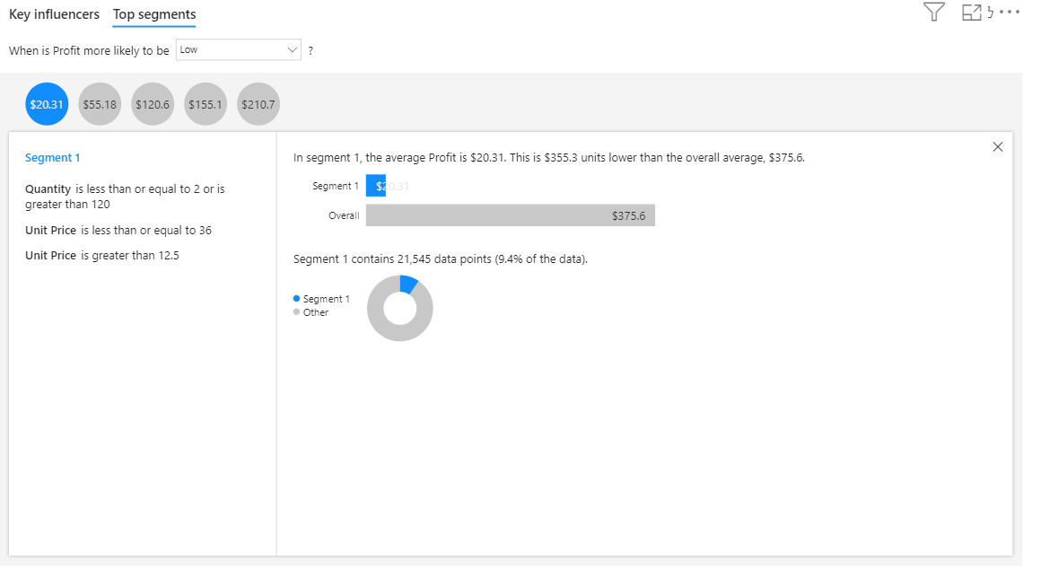

Stacked Bar Chart: Top 5 stock items based on Profit in decreasing order and if look at air cushioned machine is second highest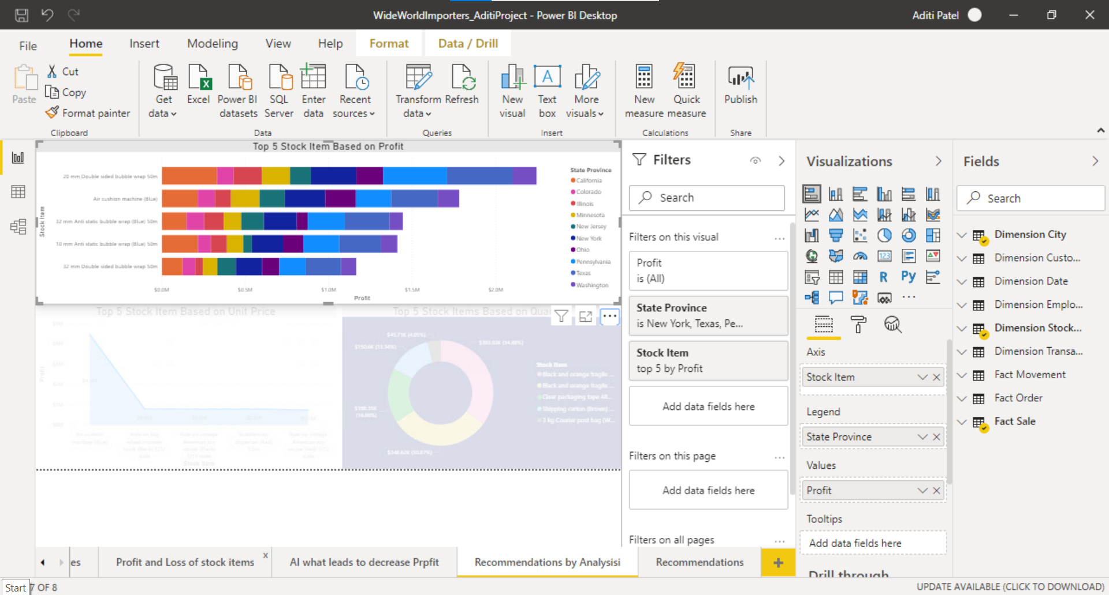

Stacked Area Chart: Top 5 stock items based on Unit Price in decreasing order and if look at air cushioned machine is highest profit-making item

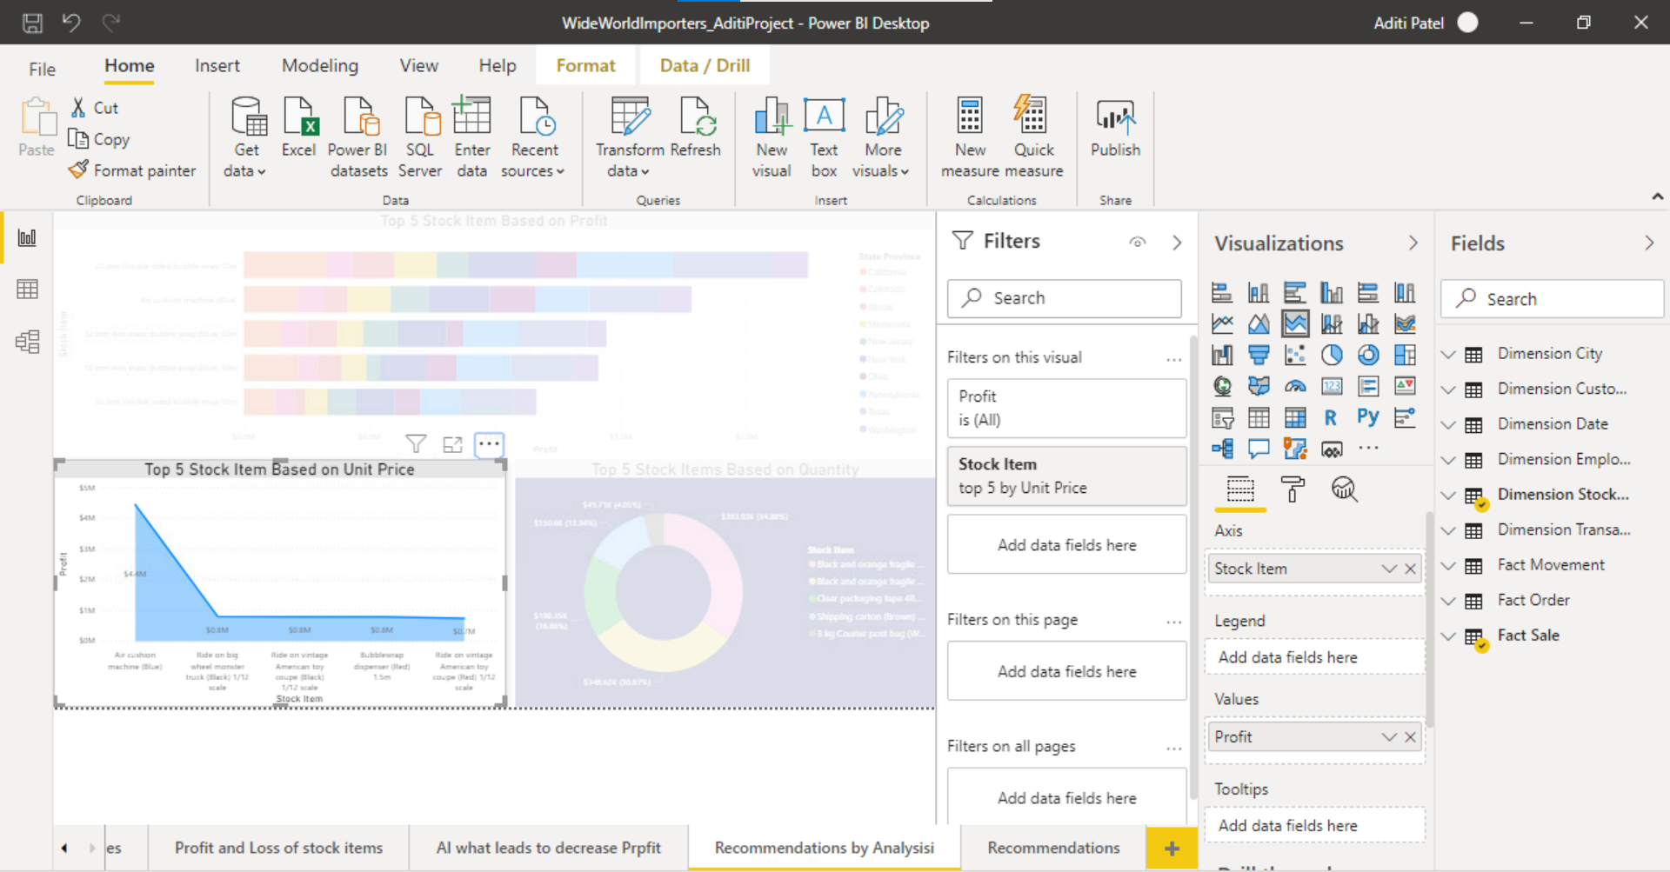

Donut Chart: Top 5 stock items based on Quantity and there is no air cushioned machine in top 5 items, which means Factor Quantity is less likely affected to profit rather than unit price

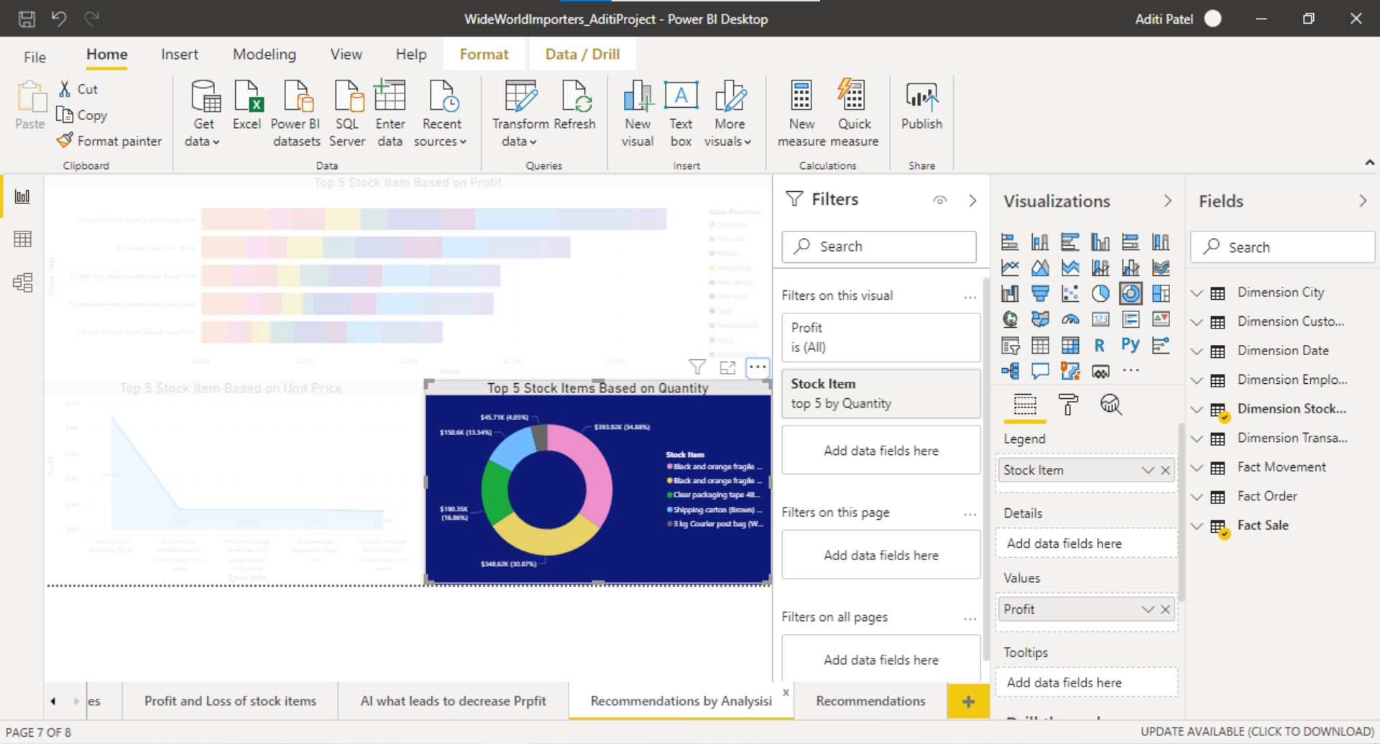

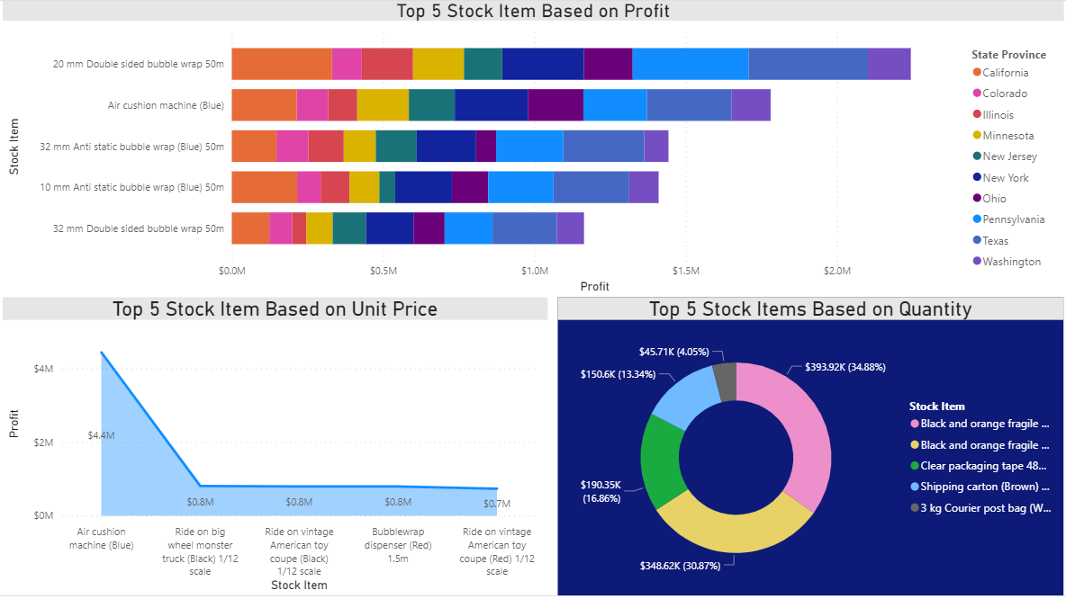

Tried to use Q&A of Power BI and connected with my analysis.

As employee id is unique It gives you distinct count of all employees so defined term as below:

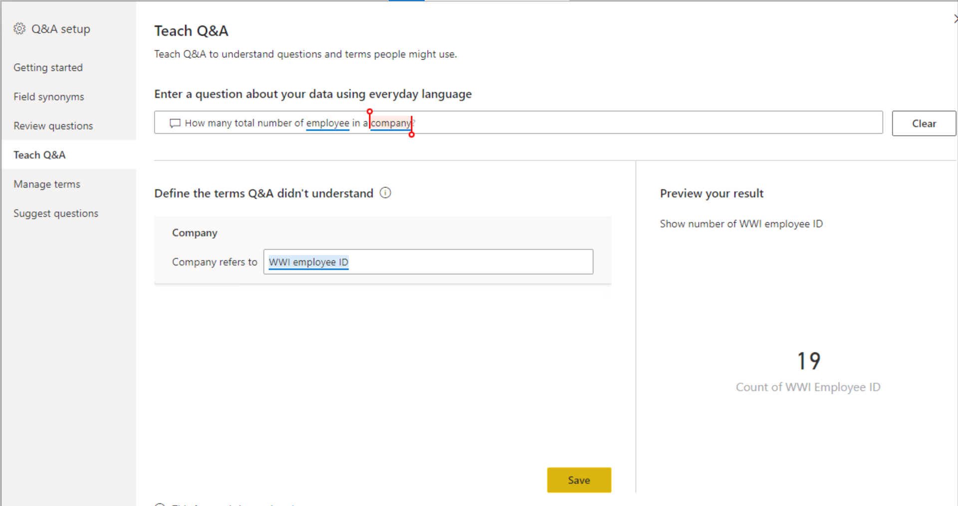

Q&A: shows 19 employees working in coming which might be a reason of not making profit in states like Hawaii as there it might be shortage of employees which results into low sale

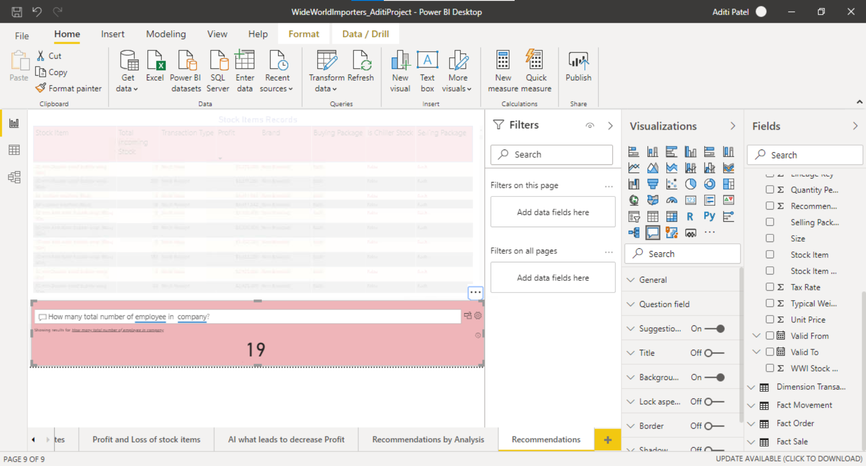

Table: Shows records of Stock Items which has detailed information of stocks movement like as we can see profit which is in brackets shows negative value and some items has low incoming stock so it might be a reason that items like Halloween Zombie masks in low stock items leads to a loss.

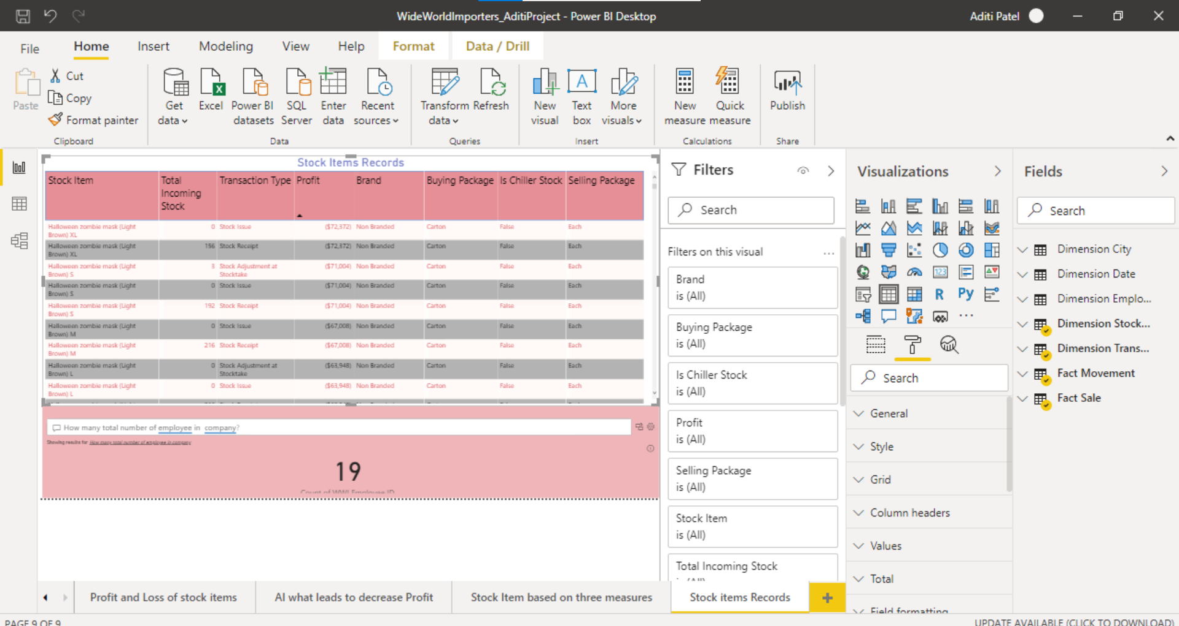

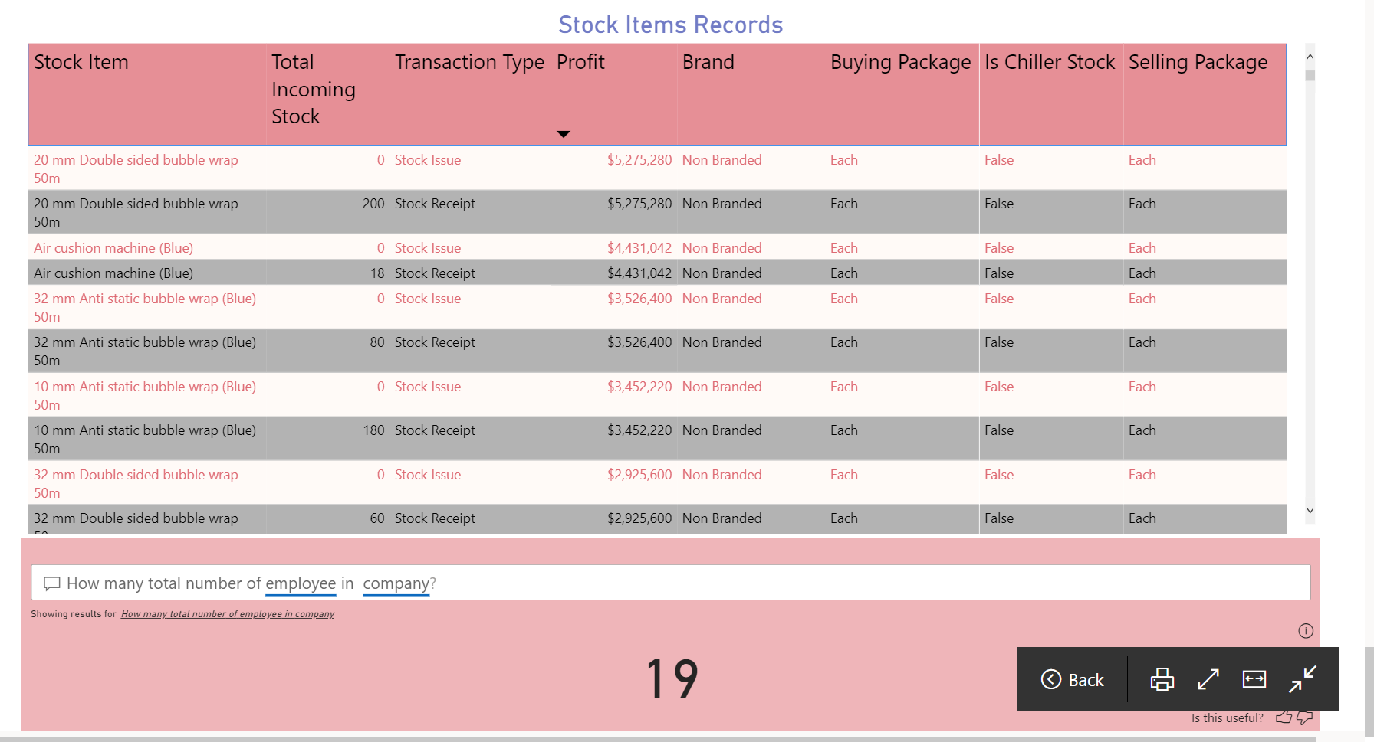

**PUBLISHING IN POWER BI FOR CREATING DASHBOARD:**

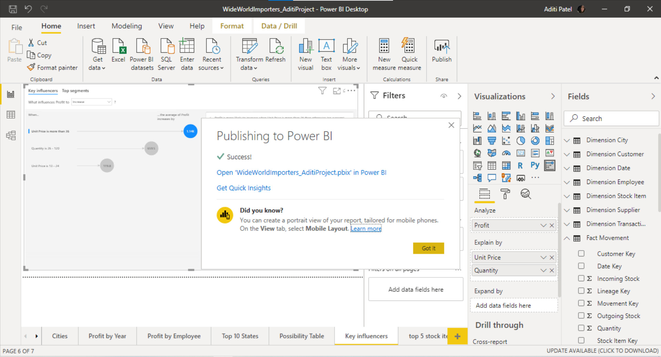

Dashboard Link: (hold ctrl + click link)

<https://app.powerbi.com/groups/me/dashboards/db2324e9-93d8-4751-861b-41421982e699>

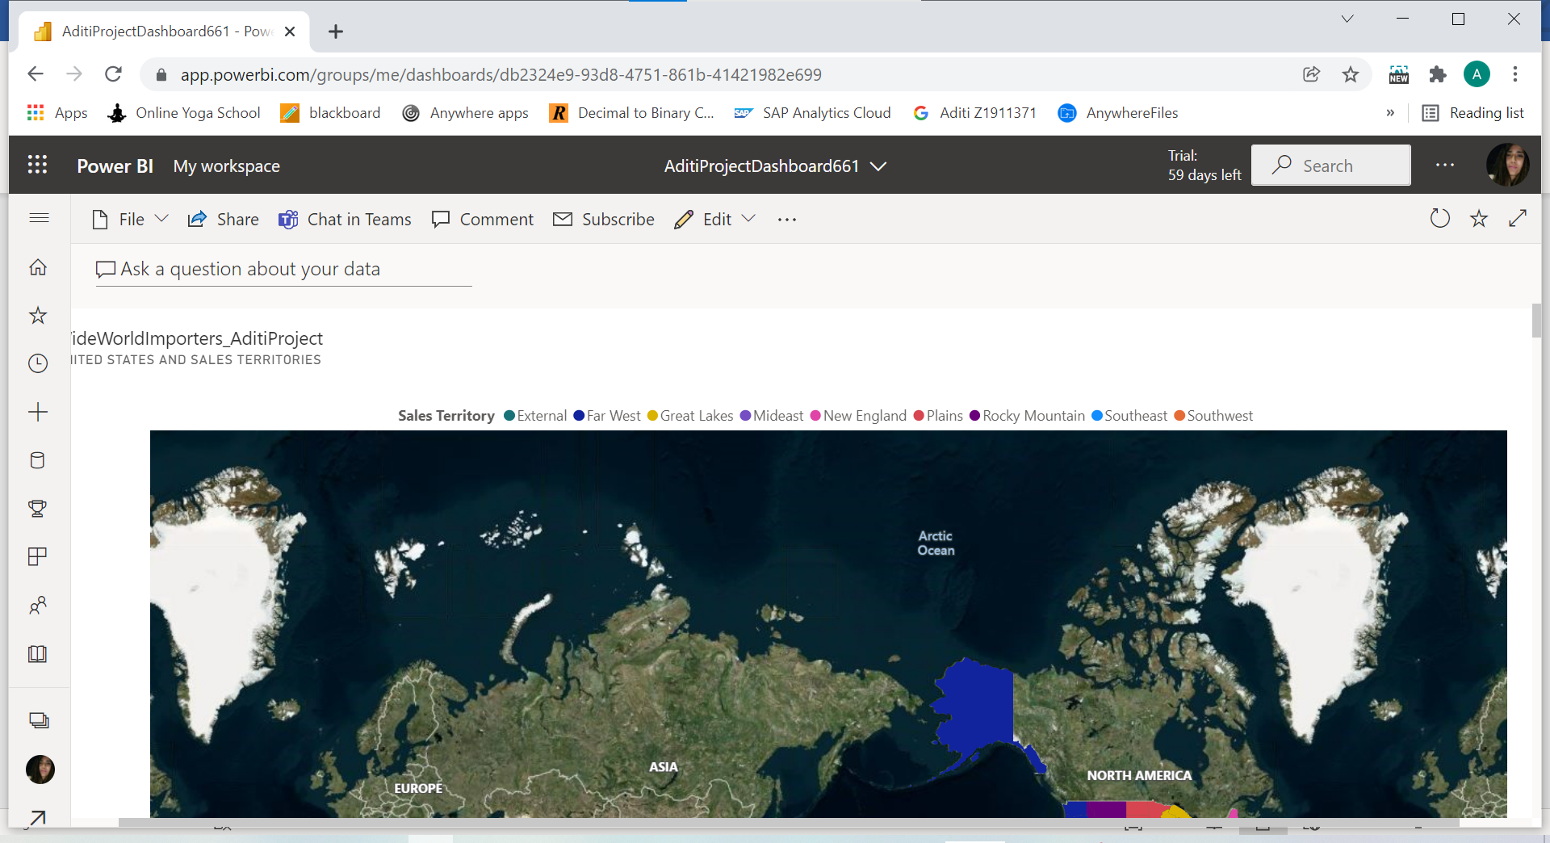

**RECOMMENDATIONS:**

* Should hire more people like Hudson Onslow and Archer Lamble or arrange some training sessions for other employees under the guidance of Productive employee.
* Should focus more on increasing Unit price.
* Concentrate on sales to the low populated states as from analysis all the top states seems highly populated, might take care of incoming goods to avoid shortage of items.
* Above points might help to maintain profit ratio and it might help to increase profit to the products like Halloween zombie masks and also to the low populated states like Hawaii.

